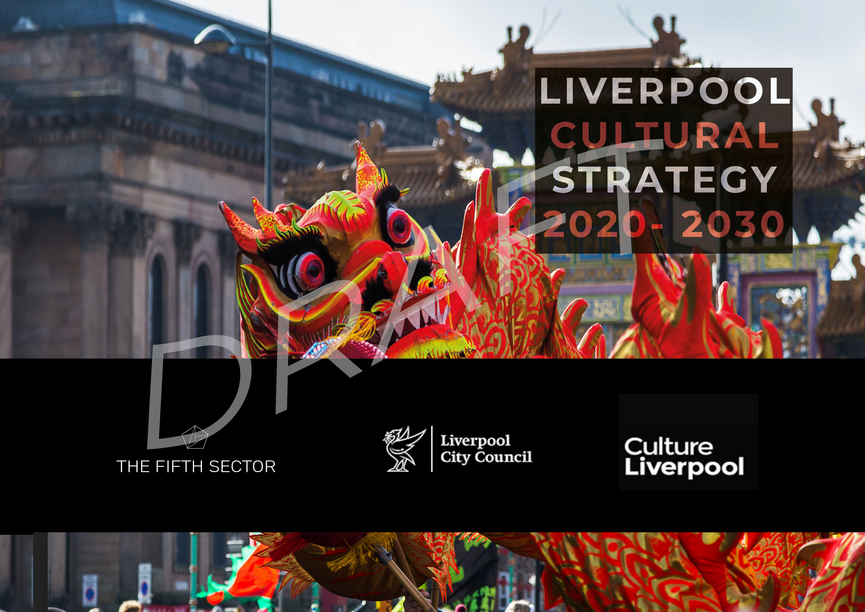

Contents
Executive summary 1
Context: Liverpool in 2020 7
History of success 9
The role of the cultural sector in recovery 11
Liverpool’s vision for culture 14
A city built on culture 14
Enlist the support of changemakers 16
Storytelling 17
Creative ambition and risk-taking 18
Framework - precedent and parallels 19
Cultural Strategy 20
Scope of the Cultural Strategy 20
Objective 1: Recover and consolidate Liverpool’s creative and visitor economy 22
Objective 2: Liverpool’s creative communities 26
Objective 3: Liverpool’s creative people 29
Objective 4: Develop Liverpool as a creative place 32
Objective 5: Grow Liverpool’s creative sector 38
Culture Liverpool Action Plan 44
Phase 1: Re-open and recover 46
Phase 2: Reassure and restart 49
Phase 3: Rebalance and renew 50
Appendix 1 - Evidence review 52
Definition of Cultural and Creative Industries 52
Appendix 2 – Consultees 59
Appendix 3 - DCMS Creative Industries Standard Industrial Classifications 60
Cultural Industries 60
Creative Industries 60
Appendix 4 - DCMS Standard Occupation Codes 61
Cultural industries 61
Creative Industries 61
Appendix 5 – LinkedIn industry codes 62

Table of figures
Figure 1 Cultural value chains 21
Figure 2 Investment principles 23
Figure 3 Community-led transformation 26
Figure 4 Liverpool’s cultural and creative ecosystem 41
Figure 5 Action plan timeline (placeholder) 51
Figure 6 Creative employment in Greater Liverpool 54
Figure 7 Sector breakdown of cultural and creative industries enterprises in Liverpool 56
Figure 8 Clustering of creative enterprises in Liverpool City Centre 57
Figure 9 SWOT Analysis 58

Executive summary
Liverpool’s Cultural Strategy sets out the role of culture in recovery of the city. It proposes a plan for ambitious events and activities which will catalyse the reopening of the city to visitors and business. In doing so, it looks back at the strengths which both Culture Liverpool and the Liverpool cultural sector developed over more than a decade and considers how more of that knowledge, capability and capacity can be transferred to the cultural and creative supply chain of the city. How can public, private and social investment help build cultural and community assets? How can Liverpool lead the way in developing a new mixed economy model that is both more creatively ambitious and outward looking, and more resilient to external shocks, whilst opening up opportunities for other kinds of funding and investment?

A city built on culture
Liverpool’s cultural success has been built on a legacy of engagement and social impact which predates Capital of Culture. Beyond the high-profile public events and celebrations, the city and its cultural organisations have built their own forms of ‘best practice’.
Now the city is determined to continue to deliver Liverpool’s brand on an international stage to fulfil its huge potential. But it is doing so with a greater awareness of how COVID-19, Black Lives Matter, and the climate emergency have demonstrated the need for its work, and that of its partner organisations, to embed the principles of equality, diversity and inclusion more strongly than ever before. The challenge for this strategy, more than at any time in the last decade, is for Liverpool to:
‘Ensure that creative engagement becomes a permanent fixture in mainstream ways of working.’
The Cultural Strategy challenges communities, artists and cultural organisations to re-imagine the future of Liverpool and help bring about the change needed to ‘build back better’ in the wake of coronavirus and subsequent recession. COVID-19 has been a turning point: we now need to understand how to better manage the production and consumption of culture in the future to generate more positive social/economic impacts in our communities with less negative impact on the environment.

The role of the cultural sector in recovery
A decade of sustained investment in culture has delivered coherent and consistent leadership from the sector. Collaboration between Culture Liverpool and cultural leaders, including through the LARC and COoL cultural networks, has helped influence and shape policy and the development of the cultural offer which has been so important to Liverpool’s renewal and growth.
The speed and agility with which the cultural sector and city partners were able to respond to the COVID-19 emergency, making support available to artists and creative enterprises ahead of other parts of the country, brought home a recognition of the value of clear and consistent leadership – and the risk of losing it. This strategy recognises the importance of defining new structures and new ways of working to address our changed realities. In this, we need ensure that succession planning reflects and builds upon this capacity for collaboration as one of Liverpool's key strengths.

Putting communities at the heart of culture
The immediate priorities for recovery and renewal are to bring communities together, reopen the city and reimagine the creative economy. The Cultural Strategy will prioritise the re-engagement and growth of cultural communities. To ensure that that investment contributes to lasting and sustainable change, it will support the development of social models of investment which build assets and capability in places and communities across the city.
The imperative to ‘build back better’ is at the heart of Cultural Strategy: to ensure that culture contributes more, and more sustainably, to the health, wellbeing and opportunity of all people and all communities across Liverpool.
This approach will deliver on the aims of the City Plan, regenerating communities, increasing exchange of knowledge across all sectors of the economy and engaging cultural, creative, social enterprise and voluntary sectors in delivery of local solutions.
It embraces and speeds the development of a mixed cultural economy: moving toward cooperation as a better, more resilient model for development, building from within rather than relying on external investors or large employers, reducing dependency on public funding.
It will exercise the principle of subsidiarity, transferring assets to the level where they have most impact and produce the most lasting benefit. Investment will focus on communities, securing equality, diversity and access.

The role of artists in transformation
Artists themselves are foremost amongst those with the appetite and ability to bring about change in their own ways:
‘Artists have the ability see the world differently. Through genuine collaboration with communities, they can create work with the potential to transform our health, education, justice system, environment, transport and regeneration. Artists and communities need to be embedded within it all.’
New forms of commissioning will encourage artists to work with local partners to create programmes and projects. This will use the assets and skills of residents to solve local problems creatively. It will in turn embed the role of culture in decision making about places and communities across the city, developing new skills and creating long-term resilience within communities.

Volunteers and local champions
Community engagement will support and develop volunteering to help individuals faced with unemployment to access new opportunities, learn new skills, and become leaders within their own communities. It will identify ‘local champions’ across culture and sport, drawn from all ages and backgrounds.
‘Our ambition over the next ten years is to be an exemplar city for cultural innovation.’
Findings from consultation
Consultation on the Cultural Strategy took place between February and August 2020 – before and during lockdown. It included artists, cultural organisations, creative enterprises, representatives of community organisations, funders and political stakeholders.
This confirmed that main concerns of participants reflected the priorities within Liverpool’s City Plan:
- Inequality – socio-economic and geographical exclusion; unequal access to education and opportunity, gender imbalances, discrimination against disabled people, and racism
- Lack of diversity in management, employment, and representation in cultural activity
- Unsustainable business models – an issue exacerbated by COVID-19, lockdown and the inevitable economic recession to follow
- Lack of innovation and talent development, leading to loss of productivity across not only the cultural sector but the whole of Liverpool’s economy
- Where the investment in arts and culture would come from in the future
- Climate emergency

The importance of culture to Liverpool, as is made clear in the City Plan, goes far beyond ‘entertainment’. Arts and culture, creative industries, education, and the visitor economy, including retail and hospitality businesses, visitor attractions, parks, and sports events, are closely linked and inter-dependent parts of Liverpool’s economy. The importance of culture to the communities and people of Liverpool extends beyond economics, to take into account the social benefits and environmental impacts of their own participation, and the opportunities afforded by culture to improve education, health and wellbeing, and access to employment. Culture influences choices about public space, built heritage and the urban environment. It provides a means of self-expression to achieve personal fulfilment, strive for social justice and address inequality and discrimination in all its forms.
The Cultural Strategy focuses on actions that the cultural sector can take for itself to build its self-sufficiency and resilience: engaging communities, making links to the private sector and creative industries economy and boosting income through commercial revenue, social enterprise and other forms of public and private sector investment.
It is, therefore, not a strategy for parks, sport, leisure, the hospitality sector or the visitor economy; but it does have implications for resourcing and provision of education, health and social care, investment, business support and infrastructure development in the city, and calls for collaborative action with both local and national actors, in both public and private sectors, in achieving its objectives.

Economic impact of COVID-19
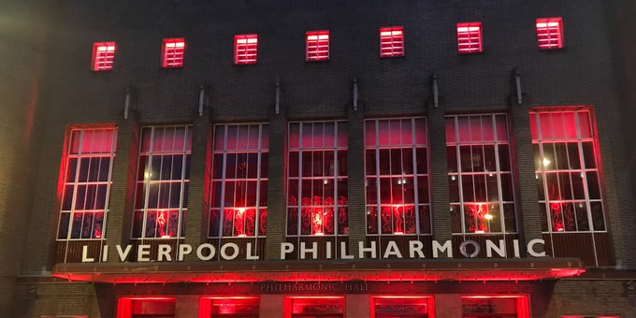

Liverpool’s creative and visitor economy has been particularly hard hit by the combination of lockdown, lack of support for freelance artists and venues, and the likely long-term impact of social distancing measures and economic recession. The crisis exacerbated structural issues both within the creative economy, and in the interdependence of culture and the city’s visitor economy.
At time of writing, thousands of Liverpool creatives are stuck at home, unable to work because of the measures to counter the COVID-19 emergency, with many of them unable to access financial support for themselves and their families owing to the changing nature of their employment status. The crisis has exposed the precarity at the heart of Liverpool’s creative and visitor economy, and brought home the need for a new model.

Loss of both technical and creative capacity in these sectors (and in associated supply chains in production services and hospitality) threatens the restart of Liverpool’s creative and visitor economy and imposes risks of long-term structural damage and loss of income for the current workforce. There are further risks of reduced opportunity and increasing inequality in access to cultural and employment opportunities.
The impact of COVID-19 will be felt in the deepest economic recession in our lifetimes. It will be a long road back and further large-scale support initiatives and significant financial intervention will be required to get people back to work, restart the creative and visitor economy and return to growth.
Investment and influencing will look to retain and provide greater security for Liverpool’s creative workforce, both employees and freelance, whilst continuing to provide opportunities for new entrants.

Liverpool Philharmonic lit up to mark the national #WeMakeEvents demonstration in support of the production services industry, 11 August 2020

Reimagining Liverpool’s creative economy
The COVID-19 emergency has already inflicted some significant losses on Liverpool’s creative and visitor economy. Important music venues, including Zanzibar and Sound, have closed, never to reopen. The sustainability of many other creative organisations has been seriously challenged.
The response to the crisis demands a reassessment of priorities, and imposes the need to make some ‘hard choices’:

‘You cannot save everyone and everything. If you spread resource thinly, everyone suffers. Strategically invest in artists, diversity, and access. Do it now.’
Jo Verrent, Unlimited
Rebuilding the live event production sector
The live events production sector is one hit hardest by COVID-19. One way to help build it back it through closer collaboration between cultural organisations and the city’s creative industries is one way in which a greater proportion of the value of the supply chain for major events can be captured in Liverpool. Future investment will consider ways in which it contributes to stimulating collaboration across the city’s arts, events, music, production services, film/television and immersive sectors.
This method of commissioning has the potential to create an internationally significant ‘smart specialism’ in large scale event production.

Even before the crisis, Culture Liverpool and the city’s cultural organisations were looking at the potential to develop a suite of shared services (ticketing, marketing, rehearsal spaces, production services and a communications portal) to save costs and identify ‘invest to save’ and ‘invest to grow’ opportunities. These principles of collaboration and identifying actions that the sector can take to secure its own future resilience and growth will be even more important now.

Liverpool as a creative place
In raising investment to continue the growth of Liverpool as a creative place, it is important that development of creative quarters – including Baltic Triangle, the Cavern Quarter and Williamson Square, the Central Business District and Ten Streets - should recognise existing clustering and use planning and devolved powers to minimise displacement of cultural and creative organisations, including those in music.
The stimulus that can be provided by existing large-scale plans – including those for Littlewoods Film Studios and the new Cruise Terminal - can catalyse more, and more ambitious, development of cultural infrastructure. Strategic coordination of planning and investment presents an opportunity to move away from developer led models to one which engages communities and businesses in establishing priorities for their local areas. This will help ensure that both regeneration of cultural districts and development of new attractions retain and build upon the cultural grain of Liverpool city centre.

Major events and celebrations
Major event programming remains central to cultural provision and destination marketing for Liverpool.
Investment in festivals over the last decade has delivered economic and social benefits to the whole city and its diverse communities. Over the next ten years, coordinated development of both sector and audiences will allow Liverpool to address wider ambitions, identifying new (commercial) revenue opportunities to develop and expand established festivals and achieve better value for public money.
Innovative responses to COVID-19 have seen events such as the Good Business Festival ‘pivot’ to online delivery – and Culture Liverpool will support proposals which use digital and immersive media to reach wider audiences.

Liverpool as a ‘playful city’
An innovative and internationalist city-wide public art strategy will complement the major events programme. This will help to create an immersive and interactive offer for local, regional, national and international audiences – both in person and online - one which reimagines the whole of Liverpool as an interactive ‘Quartier des Spectacles’.

Identifying Liverpool as a ‘playful city’ will build on the legacy of iconic events such as The Giants, Liverpool Dream, the KLF’s ‘Toxteth Day of the Dead’, The Kazimier’ s self-mythologising ‘Krunk’ parties, and Liverpool’s distinctive creative iconography (eg, Carl Jung’s statement that, ‘Liverpool is the pool of life’) to encourage setting up new ‘Liverpool Traditions’ - unique, distinctive cultural assets that attract visitors and engage local communities alike.
Supporting our key creative sectors
Building on the legacy of ACME, Liverpool Film Office and, more recently, the UNESCO City of Music Office have forged vital relationships with local creative enterprises and investors.
Over the next decade, Cultural Liverpool and LCC will work with the Growth Platform to extend the Film Office and Music Office offer and establish a portal for specialist information, advice and guidance for all sectors of cultural and creative industries – and bring a halt to the ‘moving of deckchairs’ inherent in renaming and repositioning business support and inward investment. It will collaborate with industry, Innovate UK, national sector bodies and universities to identify opportunities, business cases and significant funding for city/regional networking and creative industries cluster initiatives, to support sector growth and attract inward investment.
The same principles of collaboration will apply to devising a new theatre strategy, emphasising opportunities for collaboration between venues in commissioning, producing and promoting new work, providing new talent pathways for actors, writers, producers, directors and technical staff and reflecting the evidence that the existing ‘mixed economy’ funding model - a mixture of public support and commercial revenue, rather than direct public ownership, or solely commercial operation - is the most efficient way to operate four producing theatres and to secure their future.

Culture Liverpool will convene discussion between the theatres and Arts Council England to secure increased financial backing for this strategy to underpin its development, implementation and sustainable operation.
Equality, diversity and inclusion
The new Cultural Strategy is an opportunity to embed equality, diversity and inclusion (in line with City Plan priorities) at all levels of the city’s cultural and creative ecosystem.
The COVID-19 pandemic has had a disproportionate impact upon the most vulnerable people and places, and upon people from black and minority ethnic (BAME) backgrounds. The Cultural Strategy will provide communities, cultural and creative organisations with resources, tools and a framework to help them to challenge systemic racial and indeed, all aspects of inequality through their work, and through their operations, management, and recruitment policies.

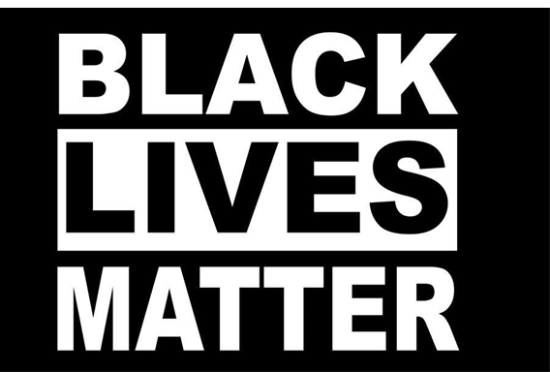
‘I'm a mixed-race lad from Liverpool. I get to play a lot of hard characters, and some people perceive that's what I'm like, but it's great for me 'cos they're always the most interesting characters.’
Stephen Graham

Storytelling
Liverpool’s is a city of storytellers; their stories connect the city’s history to its present and future. The characteristics that people from other places most immediately associate with Liverpool are those of the garrulous, friendly, funny, open nature of its people.
The people and art of Liverpool also embody several other characteristics – they are playful, resilient, independent, loyal, proud, diverse, inclusive, iconoclastic, international – which link the city to its wider region and to the other popular cultural identifiers – football, The Beatles, a great port city – which are such powerful elements of an ‘attract and disperse’ strategy for the city’s visitor economy.
Storytelling is not confined to a single sector, place or community. Liverpool continues to produce great narratives through film, television, stage, music spoken word events and festivals. Some of the stories that the city has to tell are more painful – its involvement with the slave trade, and its history of racism and sectarianism – but these are all part of a narrative of transformation, overcoming injustice and striving for equality, diversity and inclusion.

Delivering the strategy
Addressing the climate emergency
The Cultural Strategy supports Aim 5 of the City Plan:
AIM 5: A low carbon, connected and accessible city
A city with smart, clean, accessible and integrated infrastructure, where organisations, businesses and residents are all playing their part in responding to the climate emergency and speeding the city’s transition to zero carbon.
Culture Liverpool will support the efforts of cultural organisations and its own activities to accelerate the transition to net zero carbon through developing a shared carbon reduction route map with venues and promoters, and maximising clean, sustainable energy sources, to reduce CO2 emissions citywide and within our organisations, and to increase the number of enterprises undertaking formal carbon disclosure reporting.

The Cultural Strategy is ambitious; it also recognises Liverpool’s parlous financial and economic situation. To ensure that the resource and capacity is available to deliver the objectives, a phased approach to growth will see plans rolled out in three stages:
- Reopen and recover
- Reassure and restart
- Rebalance and renew
Culture Liverpool will repurpose funding and redefine outputs (i.e. moving emphasis away from audience numbers and economic outputs, toward social impacts and shared dividends) to stimulate creative risk taking and collaborations between cultural and community organisations, and between different sectors of the creative and visitor economy.
The resulting economic and environmental impact framework will align with the aims of the City Plan and the findings of consultation to assure that public funding for the action plan developed as part of this strategy will deliver:
- Improved health outcomes
- Reduced impact on front-line resources in other LCC and public services
- Cost savings and better value
- Efficiencies from coherent joint working
- Increased social and network capital, and improved relationships across the city’s culture related networks

The role of Culture Liverpool
Culture Liverpool was established after the triumph of 2008, in which the City of Liverpool delivered the most successful European Capital of Culture year to date.
Since its introduction, Culture Liverpool has continually capitalised on this success, championing culture across the Liverpool City Region through all its services and sub-brands. As Liverpool City Council’s cultural service, it has continued to build on Liverpool’s world class reputation, using arts and events as the driving force for the regeneration of the city.
The COVID-19 emergency clearly demonstrated the importance of Culture Liverpool, when it was able to quickly consult with the sector and help determine the forms of support needed by artists and creative enterprises to help them survive through the crisis.
Supported by both the City Council and Arts Council England, Culture Liverpool has developed its capacity as an executive producer and as a development agency. This strategy embeds that capacity as a resource for communities and the creative and visitor economy of Liverpool. As well as working with creative enterprises, Culture Liverpool offers a portal for large institutions, commercial promoters and community organisations to reach out and benefit from the expertise that has been built up over time within several cultural domains.
Against a backdrop of economic recession and financial austerity, this strategy suggests ways in which communities and organisations across the city can collaborate to sustain and grow the benefits of putting culture at the heart of the recovery and renewal of Liverpool.
The strategy will directly deliver Aim 6 of the City Plan – to make Liverpool, ‘The most exciting city to live, work, visit and invest’ – and contribute to delivery of the other five aims. It has five main objectives:
- Recover, consolidate and reimaging Liverpool’s creative and visitor economy
- Prioritise Liverpool’s creative communities
- Invest in Liverpool’s creative people
- Develop Liverpool as a creative place
- Grow Liverpool’s creative sector
The strategy will be delivered through a consistent framework for investment, which will reflect four key investment principles: ambition and quality; diversity and inclusion; dynamism; and environmental sustainability. It will strengthen existing partnerships and put in place guidance and support to allow new, and more diverse entrants to the sector, applying the expertise and experience developed by Culture Liverpool over the course of more than a decade:
- Recognising and rewarding best practice
- Developing, codifying and sharing measures of impact
- Sharing knowledge, experience and frameworks with the widest possible group of partners and stakeholders
- Driving national and international engagement

Context: Liverpool in 2020

History of success
Impact of Culture – 2018 in numbers
Culture Liverpool events welcomed over 2.2 million people to the city, generating more than £85 million into the local economy
Liverpool Cruise Terminal welcomed over 100,000 passengers and crew, generating an economic impact of around £7 million
LIMF attracted more than 50,000 music lovers, cementing Liverpool’s reputation as a must-visit destination and establishing LIMF as the current voice of this global music city, with an experimental but accessible programme for all
Liverpool’s Dream – Giant Spectacular in October 2018 attracted 1.3 million attendees visiting over the four days bringing in a massive £60.6m to the local economy, £58m to Liverpool, and a further £2.2m to Wirral, which attracted 80,000 visitors

From the turn of the 21st Century, Liverpool has been a beacon of culture-led regeneration. The cultural and economic life of the city has been catalysed by major events, including Capital of Culture 2008, which have transformed external perceptions of the city and with it the performance of its visitor economy.
At the same time, a strong core of arts and cultural organisations spanning all creative art forms and representing all the city’s diverse communities has built a formidable track record and consistent quality of delivery.
The cultural sector has played a crucial role in Liverpool’s renaissance and became a key element of the economy, with tourism and leisure accounting for around half of the business rates income in the city in 2019/2020.
Between 2008 and 2018, Liverpool’s visitor economy enjoyed a period of continual and uninterrupted growth. This was catalysed by the success and lasting impact of the 2008 EU Capital of Culture and driven by consistent investment in the city’s outstanding cultural offer, annual festivals and one-off events. In 2018 Liverpool City Region’s Visitor Economy was worth over £4.9bn, welcoming 67.3m visitors to the region and supporting over 57,000 jobs.

Sector development
Success in growing audiences for culture has been backed up by sustained investment in cultural production and infrastructure.
At a time when many local authorities have made cuts to cultural provision, Liverpool City Council has continued to fund a diverse range of arts organisations and cultural activity. Arts investment has gone into film/video screenings, festivals and carnivals, combined arts/multi-disciplinary arts, creative crafts, dance, drama, literature, music, visual arts & public art, digital arts, theatre and comedy.
Liverpool Film Office
Founded in 1989 as the UK’s first independent film office, over the past 10 years the office has attracted over £100m of inward investment into the local economy from large scale feature film and high-end TV drama. It generates economic impact of approximately £11.5m per year, improves the perceptions of the city internationally and protects businesses and jobs in the creative, hospitality and retail sectors.
UNESCO City of Music Office
Established in 2018, the UNESCO City of Music Office (run along lines of Liverpool Film Office) was set up to streamline engagement between Liverpool’s music sector, its investors and all statutory functions of Liverpool City Council (and other local authorities across the city region).
It also supports the activity of the Liverpool City Region Music Board, promotes development of specialist creative and leadership skills for the music industry (including through LIMF Academy) and works to secure inward investment.
Headwinds: Brexit, climate emergency, and COVID-19
2019, with its uncertainties over Brexit, saw the first slowing of growth in visitor numbers in a decade. In July 2019, Liverpool City Council declared a Climate Change Emergency and called for collective action to make Liverpool a net zero carbon city by 2030. Climate emergency presents the most fundamental set of structural and human challenges – including how we make, consume and travel to culture.
Then, in 2020, coronavirus struck, inflicting serious damage on Liverpool’s creative and visitor economy and irreversibly altering previous economic certainties.
During the 2020 pandemic and lockdown the visitor and leisure economy sectors have been the hardest hit and are likely to be the slowest to recover. This is a nationwide issue, but particularly crucial to Liverpool where the economy and the city as a whole are particularly reliant upon visitor spend. The impact has already been felt in
- People out of work across creative and visitor economy
- Events and festivals cancelled
- Venues closed
At this time, thousands of creatives are sitting at home, frustrated and unable to work. Some of them are unable to access Government support for themselves and their families. Opportunities for young people leaving the city’s schools, colleges and universities have been closed down. Iconic music venues, including Zanzibar, Parr Street Studios and Sound, have closed; many others are under threat, anxiously awaiting confirmation of when they may be allowed to reopen, and under what terms.
There will be ongoing and unforeseen impacts still to come.

The role of the cultural sector in recovery
There is no question that the COVID-19 lockdown has seriously disrupted Liverpool’s creative and visitor economy. The cultural sector is now faced with a dramatic, urgent and transformative challenge to existing structures and ways of working:
Impact of COVID-19 on Liverpool’s creative and visitor economy
Film and television: with the arrival of coronavirus, some 90% of Liverpool’s film and TV projects were immediately postponed for safety of both cast and crew. Without a major broadcaster, large commissioning organisation or studio complex to sustain employment, thousands of freelance workers were made unemployed at a stroke.
Music, entertainment and performing arts: theatres and venues were among the first organisations to close and will be amongst the last public spaces to be reopened, putting many organisations, venues and creative workers at risk. Some music venues have already closed permanently; others may never reopen. The future of the city’s large production services sector, which contributes at least £7.6 million GVA, is uncertain.
Visitor economy: enforced closure, social distancing, constraints on leisure and international travel and public concerns about safety mean that Liverpool’s visitor attractions and hospitality businesses have endured what has been described as ‘three winters’, with increased costs to safeguard returning staff and customers and massively reduced takings.
- Will it be possible to re-open the remainder of
Liverpool’s cultural venues, large and small?
- How many cultural organisations and creative
businesses will fail to survive the crisis?
- How will those which do survive find the resource to transform their management and operations in order to be sustainable?
- What will be the long-term effect on the creative workforce?
- How many of those now unemployed will find work in the sector again?
- How many potential new entrants, deprived of that opportunity, have been lost to the sector forever?
However, the City has been swift to gather a coalition from across the cultural, creative, retail and leisure sectors to develop and deliver innovative interventions to help sustain the existing business base and aid the reopening of the visitor economy sectors. Initial proposals are contained in Liverpool’s Economy Recovery Plan. Initiatives such as Without Walls– which addresses the challenges of social distancing as an opportunity to turn on its head the traditional approach to the way that audiences come together collectively - are already beginning to go into delivery.

City Plan
The impact of COVID-19 will be felt in the deepest economic recession in our lifetimes. It will be a long road back and further large-scale support initiatives and significant financial intervention will be required to get people back to work, restart the creative and visitor economy and return to growth.
Within all this is the imperative to build back better: to ensure that culture contributes more, and more sustainably, to the health, wellbeing and opportunity of all people and all communities across the city. This connects the Cultural Strategy to the new City Plan.

City Plan Aims

1. A healthier, happier, fairer Liverpool for all
2. People are educated to succeed throughout life
3. Safe and thriving neighbourhoods
4. A strong and inclusive economy
5. A low carbon, connected and accessible city
6. The most exciting city to live, work, visit and invest

City Plan Aim 6: The most exciting city in the UK
Culture, sport and creativity is Liverpool’s USP and makes the city attractive for residents, workers, visitors and investors.
Priorities and Outcomes:
- Rebooting the visitor economy through delivering major events and initiatives, and supporting the creative, cultural and visitor sectors to drive the city’s economic recovery.
- To attract visitors to the city centre through creative initiatives which reimagine the use and animation of space
- To deliver a new cultural strategy for the city, with initiatives to support sector recovery and sustainability, and to increase diversity and ambition
- To deliver The Good Business Festival and high-profile cultural and sporting events
- To grow key sectors within the city’s creative industries and visitor economy
- Expanding the use of high quality cultural, creative and physical activity initiatives which engage, empower and unite communities.
- To embed the Creative Communities approach between partners and communities, utilising culture, creativity and physical activity to aid the delivery of all City Plan aims
- To increase community participation, confidence and integration
- To increase opportunities for all residents to engage in creative, cultural and physical activities and experiences, including through improved digital engagement
- Positioning Liverpool as a distinctive, outward-facing, globally attractive city with a strong and diverse cultural identity
- To celebrate and strengthen the sustainability of the city’s ambitious, dynamic and diverse culture and heritage organisations
- To deliver a compelling destination strategy and support the visitor economy
- To attract and retain talent, and more closely align the creative civic engagement of Liverpool’s universities with the ambitions of the City Plan
- To develop the city’s appeal as a centre of sporting and music excellence
- Protecting and enhancing Liverpool’s distinctive public realm, built and natural environment, and its cultural heritage
- To apply consistently high quality urban design and public realm principles to ensure new developments are accessible and contribute to creating sustainable, healthy and active communities
- To develop and implement a strategy for reimagining the city centre
- To promote public art and maintain a distinctive sense of place
- Developing a mixed night-time and visitor economy which is representative of, and accessible to, all of our residents
- To broaden the offer and increase accessibility and feelings of safety so that everyone in the city can benefit from Liverpool’s visitor, cultural and event offer
- To showcase and market the city’s contemporary, vibrant and diverse music offer

Liverpool’s vision for culture
Liverpool’s Cultural Strategy sets out the role of culture in recovery of the city. It proposes a plan for ambitious events and activities which will catalyse the reopening of the city to visitors and business. In doing so, it looks back at the strengths which Culture Liverpool has developed over more than a decade and considers how more of that knowledge, capability and capacity can be transferred to the cultural and creative supply chain of the city. How can public, private and social investment help build community assets? How can Liverpool lead the way in developing a new mixed economy model that is both more creatively ambitious and outward looking, and more resilient to external shocks, whilst opening up opportunities for other kinds of funding and investment?

A city built on culture
Liverpool’s cultural success has been built on a legacy of engagement and social impact which predates Capital of Culture. Beyond the high-profile public events and celebrations, the city and its cultural organisations have built their own forms of ‘best practice’. (See ‘Framework – precedent and parallels’, below)
The challenge for this strategy, more than at any time in the last fifteen years, is:
‘To ensure that creative engagement becomes a permanent fixture in mainstream ways of working.’
The Cultural Strategy emphasises the role of artists in re-imagining the collective future of Liverpool and bringing about the change needed to ‘build back better’ in the wake of the COVID-19 emergency and subsequent recession.
Putting communities at the heart of culture
The immediate priority for recovery and renewal is to bring communities together, reopen the city and reimagine the creative economy. The Cultural Strategy provides a framework for Culture Liverpool to retain its and the sector’s focus and ambition based upon:
- Investment in communities and place
- Shared frameworks for continuity and consistency of delivery and measurement
- Re-establishing and strengthening creative supply chains and infrastructure
- Commissioning ambitious and risk-taking work
- National and international engagement
COVID-19 has been an inflection point: we now need to understand how to manage how we produce and consume culture in the future with less impact on the environment and more positive social impacts in our communities.
Sustainable Development Goals
The United Nations Sustainable Development Goals (SDGs) provide a blueprint for countries to create a more prosperous and equitable future by 2030. The Goals identify a series of interlinked challenges, recognising that ending poverty must be connected to strategies which address health, education, economic growth, and climate change.
The Cultural Strategy will support the organisations to connect their work to SDGs, in the belief that culture is essential for long-term wellbeing and prosperity. Cultural activity provides a powerful route to engage and raise public awareness of the SDGs, accelerate collective actions and behaviour change.
Culture Liverpool commits to regularly reviewing and reporting progress on SDGs.

Building back better means putting culture at the heart of renewal and extending the opportunity to all people, to all communities, to all sectors of the creative and visitor economy and to all parts of the city.
Those priorities have shaped and focused this strategy: all other priorities follow on from the need to re-engage communities in order to embrace new ways of thinking about the resilience and sustainability of Liverpool’s cultural sector.
This urgent reappraisal has led to a clear conclusion that there is one priority which takes precedence over all others: collaboration between arts organisations and community groups which aims to bring communities together, raising engagement and participation.
This conclusion is reached because it reflects the way in which Liverpool has successfully built on its cultural foundations in the last two decades. That renewed engagement, reaffirmed and deepened by the swift and imaginative response to the COVID-19 emergency demonstrated by the city’s cultural organisations, builds on past and current excellence. It also marks the path for a journey of recovery, renewal and reimagining of culture and creative industries from which all Liverpool’s communities will emerge stronger, more resilient and with greater recognition of their distinctiveness, radicalism and ambition than in the past.

Enlist the support of changemakers
The cultural sector does not look for a return to ‘business as usual’. Artists and creative organisations have been inspired by the speed of change and decisiveness of actions that have been taken to address the COVID-19 crisis.
Constraints on Council budgets call for innovation and new partnerships between public, voluntary and cultural organisations. In this, there is an increased recognition of the value of partnership between the cultural sector and organisations, communities and individuals with new models of social innovation and enterprise.
It is through partnership that the cultural sector can best bring about its own transformation whilst contributing to the renewal and renewal of Liverpool and the Aims of the City Plan:
- Partnerships that bring together arts practitioners with health and social care in delivery of mental health and wellbeing
- Partnerships with education providers to ensure that every child has the opportunity to take part in cultural activity, and that creative talent pathways to employment are clearly signposted and well supported
- Engaging young people in the decisions that affect their future participation and opportunities in culture
- A public art strategy which contributes to people’s sense of pride in their area and in the city centre, delivers engaging and ‘quality’ artworks, and helps deliver safe and thriving neighbourhoods in every corner of Liverpool
- Recognising the potential to learn from and develop sustainable business practices in partnership with the community, voluntary and social organisations, promoting inclusive growth and increasing and building upon community assets
- Emphasising the relevance and importance of Sustainable Development Goals in developing a sustainable and flourishing economy with opportunities for all Liverpool’s communities and people
- Working with universities, low carbon industries and the cultural sector to find innovative ways to address the climate emergency and contribute to making Liverpool a net zero carbon city by 2030
- Demanding equality, diversity and inclusion in all aspects of Liverpool life, and celebrating this through its culture
Artists themselves are foremost amongst those with the appetite and ability to bring about change in their own ways:

‘Art that cannot shape society and therefore also cannot penetrate the heart questions of society, [and] in the end influence the question of capital, is no art’

Joseph Beuys
Climate emergency
The Cultural Strategy supports Aim 5 of the City Plan:
AIM 5: A low carbon, connected and accessible city
A city with smart, clean, accessible and integrated infrastructure, where organisations, businesses and residents are all playing their part in responding to the climate emergency and speeding the city’s transition to zero carbon.
Culture Liverpool will support the efforts of cultural organisations and its own activities to accelerate the transition to net zero carbon through developing a shared carbon reduction route map with venues and promoters, and maximising clean, sustainable energy sources, to reduce CO2 emissions citywide and within our organisations, and to increase the number of enterprises undertaking formal carbon disclosure reporting.

Storytelling
Liverpool’s is a city of storytellers; their stories connect the city’s history to its present and future. The characteristics that people from other places most immediately associate with Liverpool are those of the garrulous, friendly, funny, open nature of its people.
Liverpool is the spiritual home of the sea shanty
The people and art of Liverpool also embody several other characteristics – they are playful, resilient, independent, loyal, proud, diverse, inclusive, iconoclastic, and international. These link the city to its wider region and to the other popular cultural identifiers – football, The Beatles, a great port city – which are such powerful elements of an ‘attract and disperse’ strategy for the city’s visitor economy.
Storytelling is not confined to a single sector, place or community. Liverpool continues to produce great narratives through film, television, stage, music, spoken word events and festivals. Some of the stories that the city has to tell are more painful – its involvement with the slave trade, and its history of racism – but these are all part of a narrative of transformation, overcoming injustice and striving for equality, diversity and inclusion.

Creative ambition and risk-taking
‘Our ambition over the next ten years is to be an exemplar city for cultural innovation’

The Cultural Strategy will seize the opportunities for innovation presented by re-opening of the city in new ways to develop an agenda of risk-taking, bold, exciting new work that reinforces Liverpool’s global status.
The strategy is linked to an action plan to move from recovery through local commissioning in the next 6-12 months, to opening out to a new international perspective, which will:
- Relaunch the city through a themed year of activities around the theme of What’s New for Liverpool?
- Develop a 3-5 year programme to remind past visitors of their past experience and encourage them to return, and encourage new visitors on the strength of reviews and social media perception of the last event
- Consult with artists and local community organisations to accompany this with commissioning of new work which sets out Liverpool’s distinctiveness and civic pride, within a defined programme of employment and volunteering opportunities
- Establish a framework for medium to long term partnerships between Culture Liverpool and the cultural sector to develop major capital projects, events and strategic plans for increased collaboration – including between larger and smaller cultural organisations, and across different sectors of the creative and visitor economy - to develop bids for national funding
In support of this strategy, Liverpool’s Cultural Strategy Group will work with ACE, creative industries, national agencies and universities to identify opportunities and funding for:
- Supply chain development, encouraging local and national businesses to purchase products and services from Liverpool creative businesses
- Revenue for new kinds of experimental, experiential, multidisciplinary work
- Capital for creative technology development, including immersive and interactive venues and demonstrators
- Business growth, working with the Growth Platform to develop a specialist creative IP capacity to provide information, advice, guidance and support to creative enterprises seeking equity investment
- Inward investment promotion, including a range of incentives (eg, soft landing spaces) and support (eg, recruitment and resettlement packages) to attract creative enterprises to Liverpool
- International partnerships, leveraging existing contacts and partnerships (eg, UNESCO, CBBC) to establish international exchanges, placements and bursaries for Liverpool-based artists and creative businesses

Framework - precedent and parallels

The ‘case for change’ is a case for recognising the best practice which already informs work across the city; and is more relevant now than it ever has been.
The final version of the strategy will include case studies of cultural highlights and achievements.
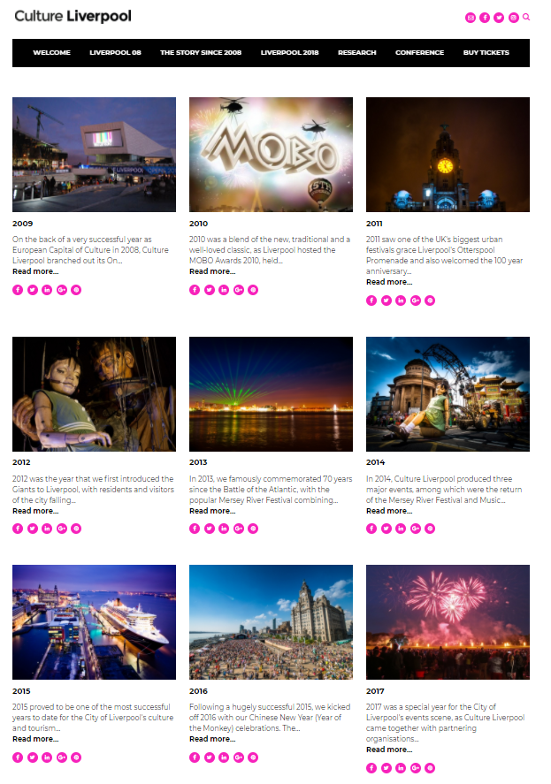

Cultural Strategy

Case for change
Consultation on the Cultural Strategy took place between February and August 2020 – before and during lockdown. It included artists, cultural organisations, creative enterprises, representatives of community organisations, funders and political stakeholders.
This confirmed the main concerns of participants as:
- Inequality – socio-economic and geographical exclusion; unequal access to education and opportunity, gender imbalances, discrimination against disabled people, and racism
- Lack of diversity in management, employment, and representation in cultural activity
- Unsustainable business models – an issue exacerbated by COVID-19, lockdown and the inevitable economic recession to follow
- Lack of innovation and talent development, leading to loss of productivity across the LCR economy
- Climate emergency

Scope of the Cultural Strategy
The importance of culture to Liverpool, as is made clear in the City Plan, goes far beyond ‘entertainment’. Arts and culture, creative industries, education, and the visitor economy, including retail and hospitality businesses, visitor attractions, parks, and sports events, are closely linked and interdependent parts of Liverpool’s economy. The importance of culture to the communities and people of Liverpool extends beyond economics, to take into account the social benefits and environmental impacts of their own participation, and the opportunities afforded by culture to improve education, health and wellbeing, and access to employment. It influences choices about public space, built heritage and the urban environment. It provides a means of self-expression to achieve personal fulfilment, achieve social justice and address inequality and discrimination in all its forms.
The Cultural Strategy focuses on those actions that the sector can take for itself to build self-sufficiency, engage communities, make links to the private sector and creative industries economy and to boost income through commercial revenue, social enterprise and other forms of public and private sector investment. It covers a wide range of art forms, enterprises and occupations, including all those recognised by the Department of Digital, Culture, Media and Sport’s definition of Cultural and Creative Industries; and sets these in the context of Liverpool’s communities, culture, heritage, assets, and economy.
It is, therefore, not a strategy for parks, sport, leisure, the hospitality sector or the visitor economy; but it does have implications for resourcing and provision of education, health and social care, investment, business support and infrastructure development in the city, and calls for collaborative action with both local and national actors in both public and private sectors in achieving its objectives.

Cultural value chains
The many elements of culture can be distilled into four main value chains, reflected in Figure 1. In addition to the relationship between cultural production (broadly, cultural and creative industries) and consumption (audiences and visitors), the strategy prioritises the relationship of Liverpool’s communities and people to culture, and the important role culture plays in achieving the objectives of the City Plan to direct investment and services in a way that brings about fair outcomes for all citizens. It recognises, too, that investment decisions about infrastructure (buildings and provision of support for corporate and institutional structures) have a profound influence on capacity and opportunity.

Figure 1 Cultural value chains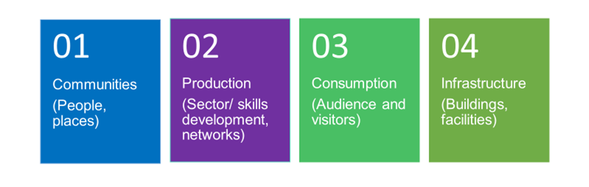
Source: The Fifth Sector (2020)

Objective 1: Recover, consolidate and reimagine Liverpool’s creative and visitor economy

1.1 Reimagine Liverpool’s creative economy
The COVID-19 crisis demanded a reassessment of priorities:
‘You cannot save everyone and everything. If you spread resource thinly, everyone suffers. Strategically invest in artists, diversity and access. Do it now.’
It also brought home some truths about the need to find new ways of working in order to recover, consolidate and rebuild the cultural and creative sector in Liverpool:
- The importance of doing more with less
- The speed and agility with which the cultural sector and city partners were able to respond to the COVID-19 emergency and make support available to artists and creative enterprises ahead of other parts of the country brought home a recognition of the value of clear and consistent leadership – and the risk of losing it. This emphasises importance of strong governance at a sector and organisational level; succession planning, with a strong, collective voice; a definition of new structures and the definition of new ways of working as well as acknowledging that that collective strength is one of Liverpool's key strengths
- Those new plans are an opportunity to embed equality, diversity and inclusion (in line with City Plan priorities) at all levels of the city’s cultural and creative ecosystem
The crisis also gave leaders confidence in their ability to reduce dependency on external agencies and inward investors – many organisations went ahead and did things for themselves. In the process, new forms of leadership and collaboration emerged which can form the basis of the recovery and renewal of the sector.
The response confirmed a new set of investment principles:
- Investing in opportunity – applying what we have learnt through the crisis to future investment
- Look first to resource that exists in the city, including through partnership with other organisations
- Invest to save
- Invest to earn
In the next decade, public sector investment will seek to rebalance investment to reflect the central role of communities and social impacts of arts and culture, applying principles of
- Ambition and quality
- Inclusivity and relevance
- Dynamism, and
- Environmental sustainability
Figure 2 Investment principles
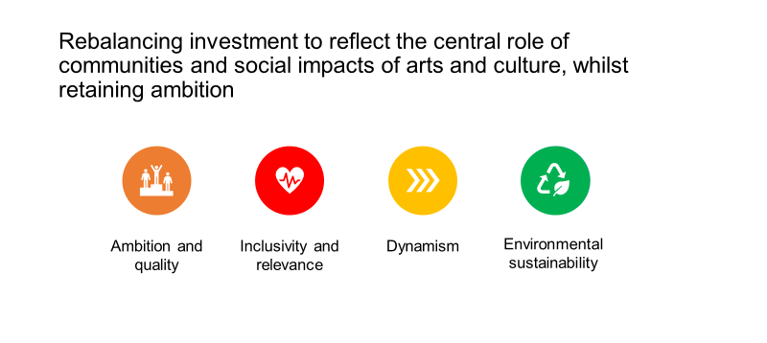

Source: The Fifth Sector (2020)

1.2 Move from competition to collaboration
Cultural Partnership
Culture Liverpool, working in partnership with Liverpool City Region Combined Authority, Cultural Partnership and the Destination Board, has a seminal role to play in helping build capacity for arts and culture across the city region.
This will build on existing collaborative approaches – such as the River Festival partnership with Wirral BC – to make the annual Borough of Culture not just an annual event, but a framework for collaborative growth. Local authority Arts Officers will have greater involvement in planning (through the Destination Board) and working with Marketing Liverpool in establishing an ‘attract and disperse’ strategy for visitors that will mutually benefit Liverpool and the city region.
The Cultural Strategy will address silo working within the creative and visitor economy.
Cross-sector working – through COVID-19 recovery groups in culture, creative industries and visitor economy coming together to promote cross-sector working and provide a forum for consultation – has demonstrated its value in the form of swift, decisive and effective decision making and action to recover and reassure the cultural sector.
Work already underway on developing shared services – has changed thinking about cross-sector working within and between creative and visitor economy businesses. Cultural Liverpool, Marketing Liverpool model and the LCR Destination Board are now aligned in their view of the benefits of:
- Aligning city marketing with ticketing
- Shared portal (ticketing and promotion) to provide a single point of entry for resident audiences and visitors
- Clash calendar – reinforcing its use to ensure a sustainable shared platform for scheduling, planning, commissioning and promotion of arts, cultural and sporting events
- Joint promotion of cultural and hospitality ‘packages’
The same principles will help the sector move toward the collaboration with public, community, voluntary and charitable agencies to look for new ways to deliver the social and environmental benefits set out in the City Plan, and in the process, identify sustainable revenues for cultural activity.

1.3 Capacity building
Supported by both the City Council and Arts Council England, Culture Liverpool has developed its capacity as an executive producer and as a development agency. This strategy embeds that capacity as a resource for communities and the creative and visitor economy of Liverpool. Whether a large institution, a commercial promoter or a community organisation, Culture Liverpool offers a portal to reach out and benefit from the expertise that has been built up over time within several cultural domains. Against a backdrop of economic recession and financial austerity, this strategy suggests ways in which communities and organisations across the city can collaborate to sustain, grow and benefit from that capacity. In so doing, this strategy puts culture at the heart of the recovery and renewal of Liverpool.
The Cultural Strategy sees Culture Liverpool assume greater responsibility in its convening and development role, to:
- Join up the cultural and creative ecosystem, promoting collaboration and more strategic approaches to event and project development
- Champion a single point of entry for sector specialist business support, supply chain and skills development for creative enterprises within the Growth Platform
- Coordinate and influence public sector policy and interventions around culture
- Share best practice built up through experience of its commissioning role for major events – acting as executive producer in support of cultural and commercial partners, engaging and catalysing the supply chain, transferring knowledge and skills

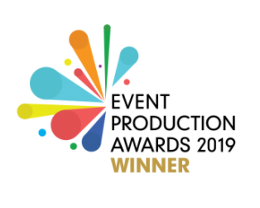

Objective 2: Liverpool’s creative communities
Figure 3 Community-led transformation

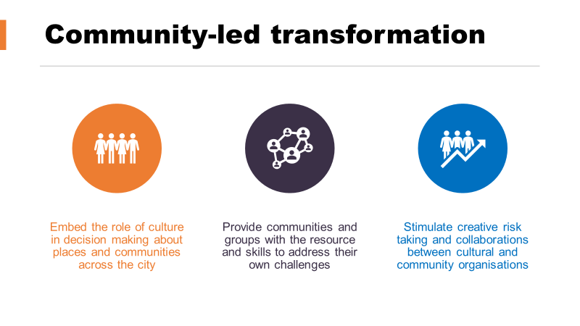
Source: The Fifth Sector (2020)
Of equal importance to sector recovery, the Cultural Strategy will prioritise the re-engagement and growth of cultural communities, and develop social models of investment.
Community-led approaches have a strong track record in establishing projects which have yielded greater results than the cash inserted into them, for example:
- Homebaked
- Princes Avenue regeneration
- Granby Four Streets and Assemble architects– winners of the 2015 Turner Prize
- Squash Nutrition on Windsor Street
The Combined Authority is increasingly looking to explore social enterprise as a pathway to inclusive and sustainable growth within communities, as signalled by its £5.5m investment into the Kindred social enterprise accelerator.
Much community-based arts activity is already organised on social enterprise lines; over the next decade, public investment will increasingly look to encourage collaboration, recognise where best practice exists in past work – and share it.

This people-focused approach will deliver on the aims of the City Plan, building local assets, regenerating communities, exchanging knowledge and offering contracts for delivery to the cultural, creative, social enterprise and voluntary sectors.
This approach embraces and speeds the development of a mixed cultural economy: moving toward cooperation as a better, more resilient model for development, building from within rather than relying on external investors or large employers, reducing dependency on public funding.
It will exercise the principle of subsidiarity, transferring assets to the level where they have most impact and produce the most lasting benefit. Investment will focus on communities, securing equality, diversity and access.
The approach will:
- Embed the role of culture in decision making about places and communities across the city :
- Use culture as part of an asset-based approach where residents are empowered (and given resource) to solve local problems creatively, with artists working with local partners to manage programmes and projects, creating long-term resilience within communities.
- Support and develop volunteering to help individuals faced with unemployment access new opportunities, learn new skills, and become leaders within their own communities
- Identify ‘local champions’ across culture and sport
This is both the immediate and most appropriate response to crisis (‘building back better’) and the strategic best option to build greater resilience for both artists and communities. It will create new opportunities for artists and community-based organisations to develop their skills, capacity and practice, over time replacing dependency on small individual grants with strategic partnerships at a local level.
Culture Liverpool will have an important role in helping convene existing community groups/leaders and cultural organisations in new partnerships. In this, it will celebrate, maintain and reinforce ‘institutional memory’, reclaiming elements of successful programmes of previous eras (eg, Creative Communities, Four Corners, ACME) in empowering local artists, creative enterprises and communities.
It will maintain a long term focus on Social Innovation and Social Return on Investment (SROI) – realising a dividend from joining up different elements of the City Plan (education, health, social care) through culture – as well as economic returns from the creative and visitor economy.
Culture Liverpool will work with LCVS and other third-sector organisations to bring social enterprise models of investment (and reinvestment) to the creative sector – developing activities and forms of governance which seek to return benefit to artists and communities, reinvesting any financial surplus in the enterprise, rather than distributing profits.
This will support the efforts of the Liverpool City Region Cultural Partnership to establish a Cultural Compact, which will in turn look to develop a Corporate Social Venture Trust to leverage increased corporate and philanthropic sponsorship for cultural and social activities.
To ensure consistent delivery of these benefits across all parts of the city, Liverpool City Council will set up a Cultural Strategy Group to deliver across communities, education and regeneration – made up of senior managers, chaired by an Associate Director and with a reporting framework to community networks and upwards to Mayor and Chief Executive.

Objective 3: Liverpool’s creative people

3.1 Retain and attract talent
At time of writing, thousands of Liverpool creatives are stuck at home, unable to work because of the measures to counter the spread of coronavirus, with many of them unable to access financial support for themselves and their families owing to the changing nature of their employment status.
The crisis has exposed the precarity at the heart of Liverpool’s creative and visitor economy, and brought home the need for a new model.
In the short term, it will prioritise commissioning spend to the development of the local supply chain and talent as part of COVID-19 recovery measures and reopening of city centre. Along with a focus on communities, employment and skills development will look to retain and provide greater security for Liverpool’s creative workforce, both employees and freelance, whilst continuing to provide opportunities for new entrants.
For artists, support for community-led initiatives will give them a role in developing more strategic programmes of activity. These may include ‘artist in residence’ schemes to place artists within other sectors (such as healthcare and education) within their communities, or as ‘innovators in residence’ in other industries.
The experience of organisations like First Take and the rapid response grants dispersed as part of COVID-19 response have highlighted demand for informal offers – eg, short film funds and microgrants. Proposals for a Creative Enterprise Allowance respond to this, providing non-refundable grants to freelancers, artists and creatives to supplement their existing income and allow them the time to focus on setting up new business and creative ventures. Culture Liverpool will work with ACE and other agencies to identify other kinds of specialist support, such as help information, advice and guidance for bid writing for artists and microbusinesses.
For employers, LCC will work with the Growth Platform to deliver and extend benefits of employer support for Apprenticeships (piloted through the Music Industry Sector Development programme) and bursaries for training to all creative industries sectors. These programmes will allow employers to address skills development for existing employees as well as new entrants.
Providing additional support and reassurance for cultural and creative industries employers aims to encourage them to ‘formalise’ contracts of employment and reduce precarity associated with freelance and seasonal contracts, helping over time to address gaps and shortages in roles calling for more experience or higher skills levels.
Culture Liverpool will work with partners in the City Council and Growth Platform to develop meetups and to encourage employers to take advantage of knowledge exchange opportunities with universities, to start to address recruitment and skills developments for jobs of the future that will make increased use of new creative technologies.
Strengthening the skills base and training infrastructure will have significant benefits for the creative economy:
- Raising skills levels in the creative workforce
- Encouraging employers to take on permanent staff rather than relying on short-term project working
- Supporting investment in skills development
- Increasing the capacity for innovation and IP development amongst Liverpool’s creative businesses
- Providing reassurance to potential investors
Children and young people
In Liverpool, we have high aspirations for all our children and young people, and a responsibility to create a city where they will thrive. Culture plays a seminal role in helping young people enjoy the best possible quality of life, have a say in matters that affect them and be able to reach their full potential. There is a lot of great, child-centred activity and participation happening in Liverpool: the Cultural Strategy and the City Council’s participation in the UNICEF Child Friendly City programme will build on this.
In a Child Friendly City all children should have a say about decisions that affect the, including on their ability to take part in and celebrate cultural activity. Culture Liverpool will encourage cultural organisations to engage with children and young people’s groups to:
- Build on their perceptions that Liverpool is a great place for young people who appreciate the events, the city centre and the sense of identity they lend
- Culture Liverpool will work with ACE and other agencies to identify other kinds of specialist support, such as help information, advice and guidance for bid writing for artists and microbusinesses
- Encourage schools, education and careers advice to work with cultural and creative organisations to highlight opportunities for creative employment
- Help cultural organisations and creative enterprises to cater better for individuals with different needs through training and awareness-raising
- Use cultural events to address the lack of youth provision in neighbourhoods and help young people feel safer in their neighbourhoods and the city centre

3.2 Increase equality, diversity and inclusion
More work is needed to address under-representation of and discrimination against minority and marginalised communities – including women, disabled people and people of colour - in the creative workforce.
Black Lives Matter
The COVID-19 pandemic has had a disproportionate impact upon the most vulnerable people and places, and upon people from black and minority ethnic backgrounds. The Cultural Strategy will provide communities, cultural and creative organisations with resources, tools and a framework to help them to challenge systemic racial discrimination and all aspects of inequality through their work, and through their operations, management, and recruitment policies.

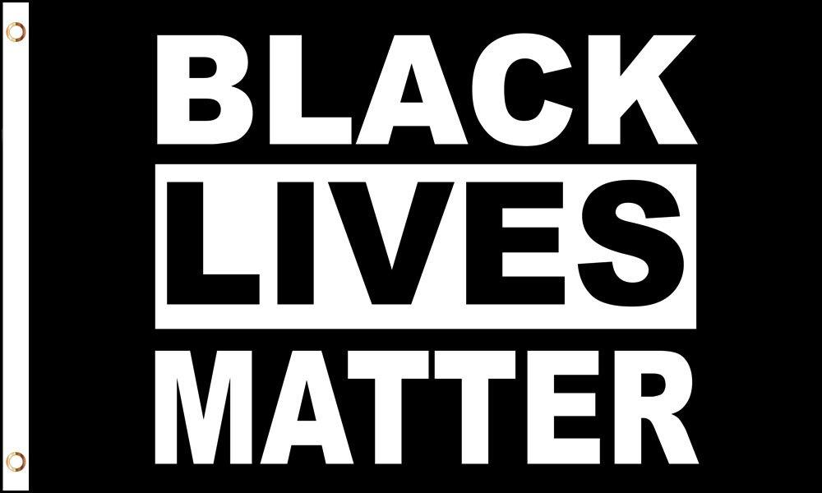

Action is needed at all levels – from careers advice to organisational leadership – and in all sectors of the creative economy. Future funding agreements for cultural and creative enterprises will include key performance indicators on diversity; and Culture Liverpool will provide arts and cultural organisations with model agreements, policies for equality, diversity and inclusion, and advice and guidance on how to improve the diversity of boards and management, behaviours and recruitment practices.
Improving information, advice and guidance and broadening access to employment opportunities within the sector for new entrants is key to addressing diversity in the creative workforce. Building on existing engagement with industry partners such as Music Education Hubs, cultural organisations will be encouraged to work with schools to improve and extend universal provision of careers advice about opportunities in the creative industries. This will include working with Growth Platform, National College Creative Industries and Screenskills to develop ‘umbrella’ mechanisms between creative SMEs and larger organisations to assure provision of careers advice in all Liverpool schools, and engaging with FE/HE about improving pathways for vocational training and Degree Apprenticeships.
This combination of measures aims to develop greater confidence among employers, investors, parents, students and the creative workforce themselves about the viability and opportunity of pursuing a creative career in Liverpool.

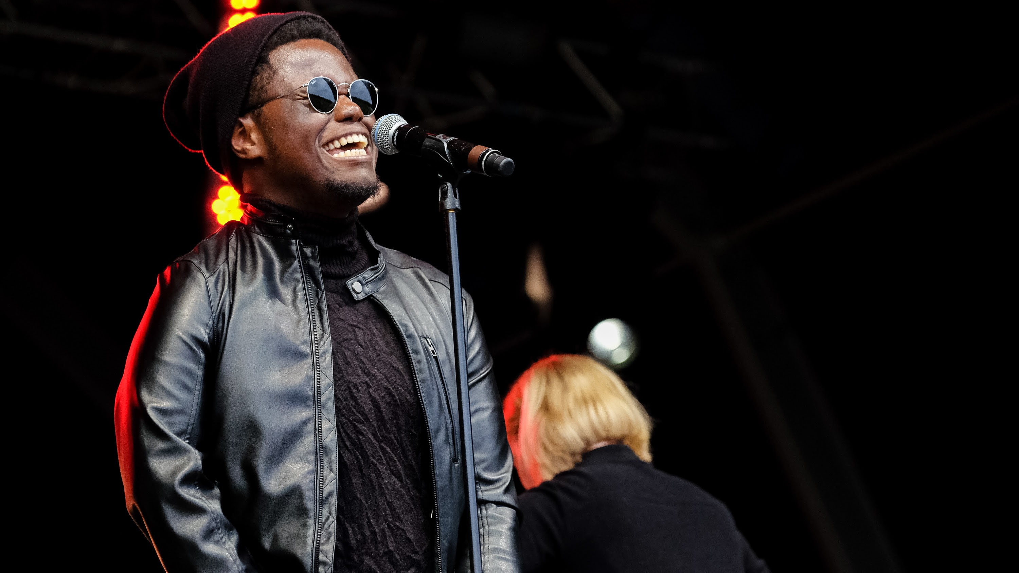
Photo: XamVolo, courtesy of LIMF

Writing on the Wall
Writing on the Wall (WoW) and the Liverpool Records Office (LRO) are bringing into public access two nationally significant collections relating to Liverpool’s Black History.
The L8 Law Centre and LARCAA were anti-racist organisations, central to the defence and empowerment of Liverpool’s communities, living under extreme institutional racism in one of the country’s poorest areas.
WoW, supported by LRO, will work with a steering committee comprised of community members and academics to review, appraise and structure the collections and bring them into the public domain. WoW will work to celebrate this achievement, ensuring that awareness is raised, locally, nationally, and internationally of the availability of the collections at Liverpool Central Library.
WoW and LRO have already worked with community members to begin to sort these collections. The Liverpool 8 archives deal with a significant period in Black British History. The library of material, amassed by LARCCA, shows a community looking outwards and challenging racism at all levels.
Unity Theatre

Unity Theatre’s ’ No One Way with…’ was a response both to lockdown and to the need to address diversity in the theatre sector. It initiated a new weekly discussion series led by different artists and industry professionals who shared their unique career journeys to date.
Unity assembled a line-up of writers, producers, directors, performers, and venue leaders to share their career journeys, in the hope of debunking some myths of what the stereotypical ‘arts professional’ looks like.
The first wave of guests included Luke Barnes (Playwright: The Young Vic, Bush Theatre & Middle Child), Ellie Claughton (Freelancer Producer: Lung, Breach Theatre, Barrell Organ), Gitika Buttoo (Director: The Octagon Theatre, Leeds Playhouse, National Theatre & CAST), Kevin Jamieson (Head of Programme, HOME), Gordon Millar (Artistic Director and CEO, Unity Theatre), Jess Thom (Performer and Deviser, Touretteshero), Matthew Xia (Director), Melissa Johns (Performer), Scottee (writer, performer and producer) and Nina Hajiyianni (Artists Director).
LIMF Academy
LIMF Academy supports Merseyside-based emerging unsigned music creators between 16-25 who display a high level of ability, activity and potential. It is supported by Culture Liverpool and PRS Foundation.
LIMF Academy works with a wide range of talent, offering relevant opportunities and experiences and access to respected industry tutors and mentors. It has done exceptionally well engaging with and developing artists from under-represented groups, including black music artists.
The programme addresses discrimination and lack of opportunity through a mixture of positive profiling of applicants and using key advocates within black music in its recruitment.
Some of the artists that have gone on to have notable success include XamVolo, Sub Blue, Jalen N’Gonda, Rvheem, IAmKyami and Remee Corry.
However, it cannot address systemic racism in the music industry alone: there is considerable work to be done to look at how these artists can sustain and progress their careers.

Objective 4: Develop Liverpool as a creative place

4.1 Liverpool’s creative districts
COVID-19 recovery measures emphasise the critical importance of reopening the City Centre to residents and visitors. The Culture Strategy will reinforce the importance of continuous improvement of the quality and diversity of the cultural offer across the city.
Strategic Regeneration Frameworks within four of Liverpool’s most significant cultural districts – the Baltic Triangle, Cavern Quarter and Williamson Square, the Central Business District and Ten Streets – are an opportunity to use their distinct character to differentiate Liverpool’s creative and visitor offer:
- Baltic Triangle: Liverpool’s digital and creative hub
- Cavern Quarter and Williamson Square: Liverpool’s ‘West End’
- Central Business District: the heart of Liverpool’s hospitality sector
- Ten Streets: a new home for making and start up creative enterprise
The coincidence of new plans for these four districts presents a unique and unrepeatable opportunity for the city to embed and promote principles of creative urbanism, and to adopt alternatives to developer-led models for the provision of new cultural infrastructure and creative workspace (eg, CICs).
It is important that development of creative quarters should recognise existing clustering and use devolved powers to minimise displacement of cultural and creative organisations, including those in music. Early intervention to establish policies to earmark Section 106 and CIL monies to specific cultural and creative uses, for example for investment in affordable workspace or cultural provision, and to enforce Article 4 provisions to limit conversion of commercial space to residential, could help retain and build upon the cultural grain of Liverpool city centre.
Policy and planning need to reconcile the distinctive character and emerging clustering of music businesses in existing music districts in the city centre, Ropewalks, Baltic Triangle and Ten Streets with demand for more recent residential and leisure development. At a time when all performance venues are under threat, it is particularly important that Liverpool makes a very public statement of intent to prevent more venues being lost – including consistently applying Agent of Change provisions (which require that new developments take account of pre-existing venues, and that provision for sound-proofing, transport plans, utilities and other amenities does not enforce changes on the existing business.)
The quality of the visitor experience and management of public realm around heritage sights (including critical entry points such as Mathew Street and Pier Head) needs to be raised; so that the cultural offer can be made integral to city marketing for both visitor economy and inward investment.
Ambition for these districts needs to be matched with a plan for sustainable reuse of cultural built heritage assets, including options for strategic divestment and alternative business models for operation of existing facilities (eg, City Halls) and a plan for built heritage across the city which takes account not only of their historic value, but of their potential to find sustainable, long-term uses as locations for creative enterprises and performance.

4.2 Multipliers and moonshots
Planned investment in new capital facilities can act as a catalyst (or multiplier) for more ambitious and strategic developments of national and international significance (moonshots).
Littlewoods Film Studios
Investment in studio and post-production capacity will allow Liverpool to secure a greater proportion of budgets for film and high-end television than location filming alone. Liverpool is now a well-established ‘brand’ for production; the new studios will address under-capacity on a national level, provide more, and more secure, employment for a range of creative and craft workers in Liverpool, and open up potential for further innovation and investment in facilities and production of new forms of screen and interactive media.
Cruise Terminal
The opening of the new Cruise Terminal, with greatly increased capacity, could catalyse other significant waterfront developments in culture and sports, including:
- NML/Tate waterfront developments
- Work with Apple Corps, DCMS and NML to realise the shared Mayoral ambition of a national Beatles archive linked to a major new (immersive) Beatles attraction
- Immersive 5G ‘Goodison Experience’ as a precursor to the new Everton stadium at Bramley Dock
Exploiting this potential of the last three of those – the ‘moonshots’, which would reinforce the profile and status of Liverpool as an international cultural destination - will require clear and strong leadership from the cultural sector to convince commercial partners and central Government of the business case for investment in Liverpool.
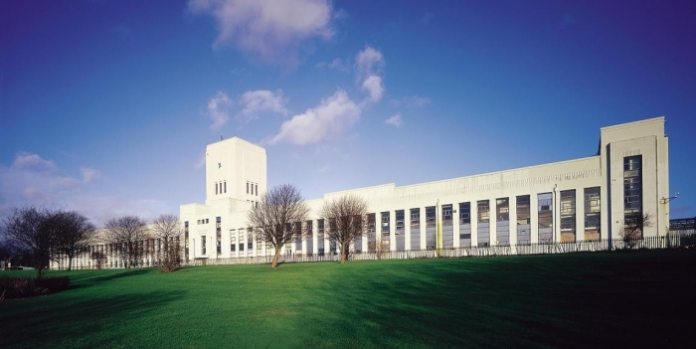

4.3 Major events and festivals
Good Business Festival

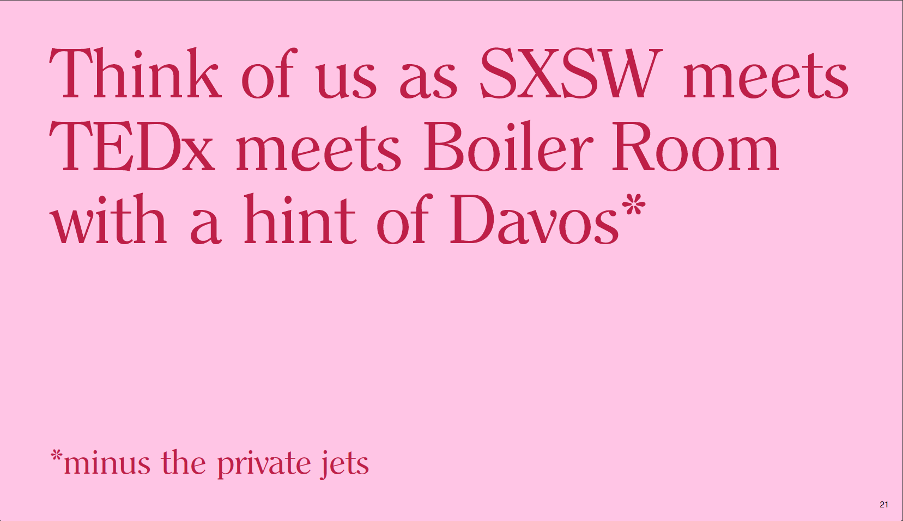

The Good Business Festival reflects the priorities of the Cultural Strategy – including the sense of social purpose which underlines the message that, ‘doing good is good business.’ The COVID-19 emergency has forced a change to the delivery mechanism for this national and international event and, once again, has inspired new innovations in its presentation and engagement.

Major event programming remains central to cultural provision and destination marketing for Liverpool.
Investment in festivals over the last decade has delivered economic and social benefits to the city and its diverse communities. For example:
- Africa Oyé is recognised as the largest celebration of African music and culture in the UK, and has grown its audience over 25+ years.
- Liverpool Irish Festival attracts funding from Irish Tourist Board and other partners, delivering great value for money and impact
The forced cancellation of a year’s events has allowed for a reassessment of the current programme:
- To identify which festivals and events represent return on the investment made in them
- To identify opportunities to tender major events on a fully commercial or partnership basis. For example, Africa Oyé now presents opportunities to develop commercial extensions on the basis of that success – in the same way as Cirque du Soleil forged a major international brand around what had been considered a ‘minority’ art form
- To look forward to new forms of events, embracing technical innovation and changes in audiences
- To explore the value of new endeavours, such as Pokémon Go! Safari, and capitalise on the opportunity to ‘pivot’ existing events into different formats, as in the transformation of the International Business Festival into the Good Business Festival (see text box) and its further pivot to an online event.

The Action Plan (below) highlights some of the major events, festivals and international sports events at ACC.
Over the next decade, coordinated development of both sectors and audiences will allow Liverpool to address wider ambitions, including:
- To consider how more of the value from the supply chain for major events can be captured in Liverpool, using commissioning to stimulate joint working across the city’s arts, events, music, production services, film/television and immersive supply chain to create an internationally significant ‘smart specialism’ in large scale event production
- Coordinating the development, sponsorship and promotion of a calendar of independent events along the lines of a ‘mini-Edinburgh Festival’ to attract larger audiences and provide opportunities for closer working with the city’s hospitality sector

‘Liverpool is the Pool of Life’
Carl Jung

4.4 Playful city
An innovate and internationalist city-wide public art strategy to create an immersive and interactive offer for local, regional, national and international audiences – both in person and online – that reimagines the whole of Liverpool as an interactive ‘Quartier des Spectacles’.
The ‘playful city’ will build on the legacy of iconic events such as The Giants, Liverpool Dream, the KLF’s ‘Toxteth Day of the Dead’, The Kazimier’ s self-mythologising ‘Krunk’ parties) and Liverpool’s distinctive creative iconography (eg, Carl Jung’s statement that, ‘Liverpool is the pool of life’) to encourage setting up new ‘Liverpool Traditions’ that appeal to visitors and locals alike.
Public Art Strategy
Culture Liverpool will work with the Cultural Partnership in development of a commission for a new Public Art Strategy for Liverpool and the city region
- Piloted as part of City Centre recovery, working out to all districts of Liverpool and the city region
- Working with the community: focusing on social innovation, health and wellbeing, education, young people, regeneration
- Embracing innovation: using interactive and immersive content to reimagine Liverpool and present content that can be enjoyed online as well as in the city itself
- Delivers engaging, high quality art, that resonates with both visitors and residents
- Builds local skills and capacity to create great public art
- Ties into sub regional assets to create a City Region Public Art Trail
The Public Art Strategy will emphasise the ambition, quality and internationalism of Liverpool’s art scene, anchored by the strength of its public and private art institutions.

Objective 5: Grow Liverpool’s creative sector

5.1 Artists and cultural organisations

Investing in the arts and artists
In an era when many local authorities have cut cultural provision and funding, Liverpool City Council (LCC) has maintained investment and funding frameworks for Arts & Cultural organisations, managed by Culture Liverpool. In 2020/21, the Cultural and Arts Investment Programme (CAIP) will fund 27 organisations to a total of £2.9million – including one-off capital grants of £640k.
In the knowledge of the need to reduce public expenditure, options for the future of the fund include:
- Impose cuts as a proportion of existing funds
- Fund fewer organisations
- Encourage bidders to identify economies of scale by combining with others in larger, more strategic pieces of work

Cultural organisations as leaders
Liverpool already boasts two well-established networks of cultural organisations – LARC and COoL – which help coordinate policy and promote collaboration across the cultural sector. The COVID-19 emergency provided great examples of the responsive of some of these organisations, and their ability to exploit their close connections in the communities within which they work, such as:
- Collective Encounters convening a national online debate about participatory theatre in a digital world
- Writing on the Wall making an effective ‘pivot’ of their annual festival to an online event, WOWFest: Lockdown, and taking the opportunity to include a range of diverse and globally significant authors (including A L Kennedy, Amrou Al-Kadhi, Irvine Welsh and Noam Chomsky)
- 20 Stories High creating digital activities for its Youth Theatre

The Cultural Strategy – and its new approaches to collaboration and co-investment - allows opportunities for these, and new players, to emerge and assume prominence in their activity.

Its focus on investment in community asset development (Objective 2, above) will increase capacity for these and other organisations to further strengthen their connections with each other, extending partnerships to other innovative social enterprises (such as Homebaked and Liverpool Heritage Company) to provide inspiration for new organisations and a new generation of cultural leaders representing the diversity and fierce creativity of Liverpool’s distinctive places and communities.

5.2 Sector specialist support
Liverpool Film Office
Liverpool Film Office’s work to develop the indigenous screen sector and to be known as the best place to make screen content in the UK accelerates with force and excitement.
The newly established Liverpool City Region Production Fund has enhanced the region’s reputation and offer for filmmakers around the globe.
The latest production by Liverpool-based Leopard Pictures benefitted from funding for their BBC children’s drama, The Snow Spider. Funding enabled Liverpool Film Office a stake in the production to ensure the production uses local crew, suppliers and locations, as well as and providing young local trainees vital on-set experience to further stimulate the region’s economy and infrastructure for filming.
In light of the fallout of COVID-19, Liverpool Film Office repurposed part of its existing funding to create the LCR Film & TV Development Fund; to provide fast-tracked support to local creative talent, supporting numerous projects to essential development activity. Awards were made to bring forward a pipeline of new content that can create jobs and investment for local crew and businesses as production resumes.
Littlewoods Studios has taken a major step forward with a £17MN commitment from the Liverpool City Region Combined Authority’s Strategic Investment Fund, with the project identified as a key component of the region’s economic recovery plan.
Part of the funding will be used to deliver temporary ‘pop-up’ studios, to capitalise on current demand for studio space and enable the region to begin to reap the economic benefits of purpose-built studio space, in advance of the main development.
Liverpool Film Office
Founded in 1989 as the UK’s first independent film office, over the past 10 years the office has attracted over £100m of inward investment into the local economy from large scale feature film and high-end TV drama. It generates economic impact of approximately £11.5m per year, improves the perceptions of the city internationally and protects businesses and jobs in the creative, hospitality and retail sectors.
As well as its support for production, The Film Office is integral to developing the supply chain for screen industries, linking writers and performers for stage with opportunities in film and tv; supporting grass roots and first-time film makers through First Take, sponsored by BFI; and creating high value jobs in innovative companies working in VFX and immersive media.

Liverpool has a blossoming digital and film industry. We want to capitalise on filming opportunities and the economic benefits they bring. Littlewoods Studios will provide Hollywood-standard facilities that will complete our world class offer.

Mayor Joe Anderson

UNESCO City of Music Office
Established in 2018, the UNESCO City of Music Office (run along lines of Liverpool Film Office) was set up to streamline engagement between Liverpool’s music sector, its investors and all statutory functions of Liverpool City Council (and other local authorities across the city region).
It also supports the activity of the Liverpool City Region Music Board, promotes development of specialist creative and leadership skills for the music industry (including through LIMF Academy) and works to secure inward investment.
Both the Film and Music Offices were integral to the COVID-19 emergency response, quickly repurposing funds and identifying creative enterprises which could benefit from additional support to keep them afloat.
Extending specialist support to all creative sectors
Building on the successes of past interventions such as ACME and Kin2Kin, over the next decade Cultural Liverpool will:
- Work with the Growth Platform to extend the Film Office and Music Office offer and establish a portal for specialist information, advice and guidance for all sectors of cultural and creative industries - bring a halt to the ‘moving of deckchairs’ inherent in renaming and repositioning business support and inward investment.
- Restart review and development of shared services (rehearsal spaces, production services, communications portal) to save costs and identify ‘invest to save’ and ‘invest to grow’ opportunities
- Help coordinate and promote sector meetups
- Work with industry, Innovate UK, national agencies and universities to identify opportunities, business case and significant funding for city/regional networking and creative industries cluster initiatives

Figure 4 Liverpool’s cultural and creative ecosystem
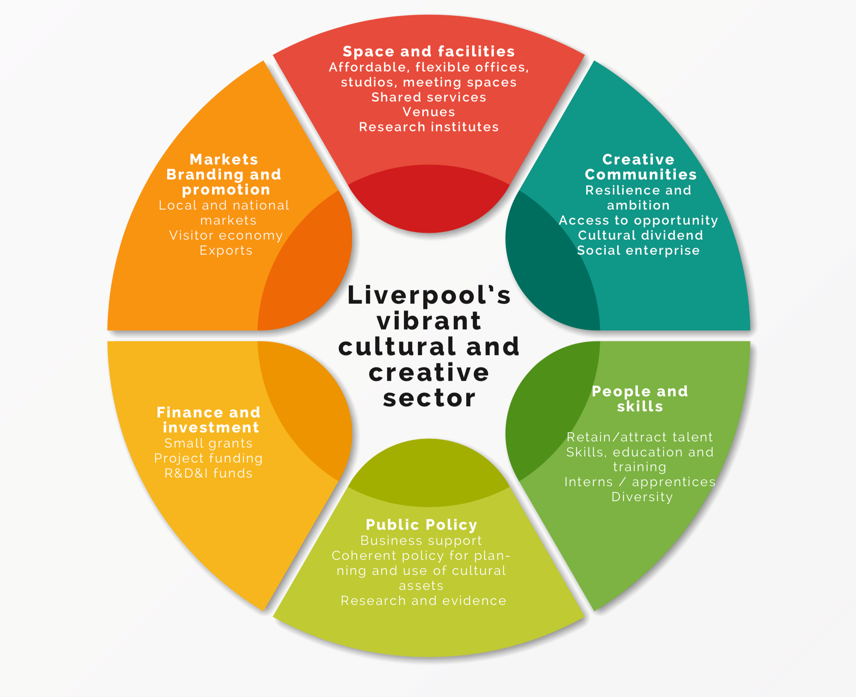

Source: The Fifth Sector (2020)

5.3 Stimulate inward investment
Sector development in the creative industries has proven to be by far the most effective way to secure inward investment.
Inward investment can complement the emphasis on self-reliance and collaboration within the Cultural Strategy to provide additional capacity and stimulus for new opportunities for creative and collaborative R&D, sharing of new ideas and technologies and creation of new IP.
The fallout from COVID-19 crisis, in particular its impact on freelance employment, highlighted that Liverpool’s creative sector needs to increase its share of earnings from IP-based activity and mitigate the risks of over-dependency on activities which depend on ‘footfall’.
- Culture Liverpool, LCC, Liverpool Film Office and the Music Office will Work with city partners (Growth Platform, universities) and national bodies (DCMS, DIT, Catapults, Research Councils, SciTech Daresbury/STFC) to:
- Identify capacity for development of the evidence base and horizon scanning needed to identify priority sectors, and opportunities in emerging creative technologies
- Identify gaps in Liverpool’s creative supply chains that present opportunities to address them through inward investment
- Develop soft landing spaces and support packages for inward investment into CCI

5.4 Theatre strategy
The findings of the Liverpool theatres review, jointly commissioned by ACE and Culture Liverpool and completed just as the coronavirus crisis hit, recognised the need for a new, collaborative model of commissioning, production and promotion that would grow and develop audiences for theatre and live performance in Liverpool.
Its recommendations now needs to be readdressed in the light of the changed economic, social and environmental landscape presented to us by COVID to arrive at a new and more sustainable model that emphasises the ‘Liverpool voice’ – the distinctiveness of the culture, heritage and radicalism of Liverpool’s diverse communities, as expressed through spoken word performance, theatre and dance.
A new theatre strategy will address these new realities:
- Emphasising opportunities for collaboration between venues in commissioning, producing and promoting new work
- Providing new talent pathways for actors, writers, producers, directors and technical staff
- Working more closely with Liverpool’s schools, colleges and universities to ensure that all the city’s young people have the opportunity to engage in live performance, whether as an audience member or a practitioner
- Raising awareness and visibility of the world-leading work in participatory theatre taking place amongst Liverpool’s non-building-based companies
- Clearly identifying the role for other performance based artforms – including contemporary dance and the work of organisations such as Merseyside Dance Initiative and Milapfest
- Embracing shared promotion and ticketing to stimulate demand and develop audiences by encouraging existing theatregoers to experiment with new forms as well as attracting new audiences
- Supporting collaborative working between Liverpool venues (in both the subsidised and commercial sector) and national companies to strengthen Liverpool’s status as an important venue for major touring productions of new work and reinterpretations of classic texts

The Theatre Strategy will reflect the evidence that the existing ‘mixed economy’ funding model - a mixture of public support and commercial revenue, rather than direct public ownership, or solely commercial operation - is the most efficient way to operate four producing theatres and to secure their future.
Digital innovation in theatre - Collective Encounters
One of the most dynamic response to COVID-19 has come from Liverpool-based participatory theatre organisation, Collective Encounters.
In 2019 Collective Encounters launched the UK’s first Centre for Excellence in Participatory Theatre to explore the notion of ‘excellence’ and participation and inform, support and advocate for the participatory theatre sector. Since its launch Collective Encounters’ Centre for Excellence in Participatory Theatre has established training programmes, a library of academic resources, toolkits and policy papers pertaining to participatory practice, a global map of participatory theatre practitioners, a series of short accessible films and a masterclass programme and seminars exploring different aspects of participatory theatre practice. In response to the COVID-19 emergency, Collective Encounters convened a series of events to address concerns of the participatory theatre workforce.
The resulting report, Delivering Participatory Theatre During Social Distancing: What’s Working? (July 2020), identified re-occurring themes, challenges and examples of practice and innovative approaches to delivering participatory theatre in a digital space.
Culture Liverpool will convene discussion between the theatres and Arts Council England to secure increased financial backing for this strategy to underpin its development, implementation and sustainable operation.

Culture Liverpool Action Plan

A phased approach
The response to the COVID-19 emergency will result in the deepest economic recession in our lifetimes. There will not be a return to ‘business as usual’. Sadly, we already not that not all the creative businesses and venues which have contributed so much to the cultural life of the city over the last two decades will survive.
Nor will the public sector have the resource to secure all pre-COVID activity. That may mean some painful choices in allocation of scarce resource; it certainly imposes a requirement for greater collaboration and the need to identify those things that organisations, and the city, can do for themselves and those which will require external support.
The depth of the crisis means that, along with the prioritisation of objectives within the Cultural Strategy, there is a clear need to adopt a phased approach to ensure that the Action Plan address recovery, restart, renewal and resilience of the sector in the correct order.
That phasing will also give organisations across Liverpool’s creative and visitor economy a chance to pilot and evaluate new collaborative approaches which look to save money, break down silo working and deliver better value and more exciting experiences to audiences.

Measuring impact
Culture Liverpool will repurpose funding and redefine outputs (ie, away from audience numbers and economic outputs, toward social impacts and shared dividends) to stimulate creative risk taking and collaborations between cultural and community organisations, and between different sectors of the creative and visitor economy.
The resulting economic and environmental impact framework will align with the aims of the City Plan and the findings of consultation to assure that public funding for the action plan will deliver:
- Improved health outcomes
- Reduced impact on front-line resources in other LCC and public services
- Cost savings and better value
- Efficiencies from coherent joint working
- Increased social and network capital
Detailed work on this will include a review of past impact measures to ensure consistency of delivery across programmes; where none exist, LCC will work with universities to develop robust, shared framework of social and environmental impact measures.

Recovering the cultural sector
Liverpool’s arts organisations have always had a strong embedded element to their work with artists and grassroots communities. From the outset of the COVID-19 emergency, they have demonstrated their resilience, creativity and leadership in their focus on recovery and reopening the city:
- They have quickly taken advantage of digital channels to stay connected to their audiences and communities, streaming live performances and virtual concerts from their living rooms to ours
- They have provided small grants to support artists, keeping the city’s creative voices heard as individuals and groups reflect and respond to lockdown through their creative process
Culture Liverpool and Liverpool City Council also responded quickly to supplement and address gas in government support schemes for artists, freelance workers and small creative businesses:
- Culture Liverpool and Arts Council England supported 12 female artists in brand new commissions as part of RISE, which pays homage to extraordinary women across the globe, offering a chance for female artists to provide a social commentary on the impact that the pandemic has had on them
- Liverpool Film Office and UNESCO City of Music Office quickly initiated a range of small grants to help creative businesses stay open and keep developing new content
The pandemic has increased the awareness of the need for cultural organisations to serve and amplify the strong voice of community groups – from online youth theatres, to online learning including creative writing, storytelling and dancing.
Throughout the crisis, creative content has continued to be made and transmitted, both addressing and easing inequality.

Phase 1: Re-open and recover

Objective
Recovery – specific challenges and short-term actions to safeguard jobs and organisations
This work reflects the interdependency of culture with other aspects of Liverpool’s visitor economy, including:
- Reopening of retail shops
- Return of cruise ships
- Easing of social distancing to allow reopening of cultural venues
- Measures to allow crowds to return to sporting events
The steps already taken to create a secure, socially distanced environment in key hospitality areas, such as Castle Street in the City Centre and Lark Lane, recognise that this may not be a ‘return to normal’, but a new accommodation of the differing needs of residents and visitors, people and traffic.
Cultural Strategy reflects this, and the appetite for change – a ‘new normal’ – expressed in consultation. The actions taken in this phase are in many ways pilots – tactical steps to establish the feasibility of new approaches, and reinforce the benefits of collaboration within and between sectors.

Priorities
Over the next twelve months, priority will be given to:
- Re-opening the city
- Identifying support for artists and local creative enterprises
- Re-engaging communities to ensure their involvement in and assent to changes in the areas where they live and work
- Winning the argument for emergency funding from national bodies
- Pressing on with pilot activity to share audience data and frameworks to increase revenue and make savings for reinvestment (with contributions from institutions)
- Prioritisation and clarity in communications
- Linking cultural venues with the hospitality sector and tour operators to encourage sharing of customer data and development of packages to offer encouragement to first time visitors and reassurance to those returning to the city for the first time since pandemic
- Providing a longer term, planned programme of activities (eg, a new season of festivals) to encourage trade promotion.
- Working with Arts Council England and national authorities to establish a plan and timeline to re-open theatres and venues

COVID-19 response – projects to reopen the city and speed recovery of the cultural sector

Without Walls
Without Walls is a concept which aims to turn on its head the traditional approach to the way that audiences come together collectively, by removing the physical and socio-demographic barriers which under COVID-19 make these conventional methods of coming together impossible. It aims to be a celebration of all aspects of the people and culture of Liverpool, so will focus exclusively on working with local communities, companies and artists and will have social impact and diversity as a standard.
Each of the projects brings together a whole range of local businesses and organisations, building new networks and creating potential opportunities for growth and new ideas.

Total Immersion
Total Immersion is designed to maximise the growth potential of Liverpool’s established immersive technology ecosystem while symbiotically supporting the Liverpool City Region’s retail, cultural, and visitor economies, post-COVID-19.
Delivered in the form of a visitor attraction with immersive digital experience at its heart, Total Immersion will develop digital experiences to transform how visitors engage and interact with Liverpool’s culture and history, with each other and with its people, whether during in-person visits, driving footfall, dwell times and engagement, or remotely through the internet from anywhere in the world, all year around, opening new revenue streams for online digital sales in the process.

Creative Enterprise Allowance
Borrowing from the principles of the original Enterprise Allowance, this annual fund will provide non-refundable grants to freelancers, artists and creatives to supplement their existing income and allow them the time to focus on setting up new business and creative ventures.
The fund will be available to graduates, established artists and people who want to leave one sector and transition into art and creativity. While part of the fund, this group will be able to access existing business support provided by Liverpool City Council and the Growth Platform to help them in this journey.
The group who are receiving the allowance, will also become part of a 'creative think tank' for the city - used by businesses and the city council to tackle big thinking challenges and better align the creative thinkers of the city to decision makers.

Animation to drive footfall into the city centre

October 2020: River of Light - Concrete Rainbows
The traditional fireworks event will be refocused around increasing the light installation aspect of the festival. The date will move forward into October half term and run for a longer period to increase ‘reasons to visit’.
This will be a major footfall driver into the city to support hospitality, aligned with a national marketing campaign.

November 2020: Letting the Light Back In
Centring on a major Son et Lumiere commission within the Anglican Cathedral, Letting The Light Back In will see the architectural lighting of key buildings across the city throughout the whole of November.
Letting The Light Back In will create a reason to visit around a new festival, and create a link between River of Light finishing and the start of Christmas celebrations.
December 2020: Christmas 2020: For You and Your Kin
The launch of Christmas lights across Liverpool One, the Business Improvement District, Albert Dock and Liverpool Convention Centre will be moved back to 3rd December.
This will enable a shorter spend window to take account of the loss of private sector revenue, whilst ensuring there are sufficient funds available for the city to maximise the opportunity that this creates.

January 2021: What’s New?
A project to kick off 2021 with positivity and ambition, this will be a range of installations, commissions, ideas and talks which tackle the question, ‘What’s new for Liverpool?’ after 2020 and COVID-19.
It will set up Liverpool as a place wanting to redefine itself in a new and uncertain world: a city which recognises that the world around us has irrevocably shifted.
What’s New will continue to build the narrative of Liverpool as a city re-energised by the challenges presented by COVID-19, not defeated by it.

February 2020: Chinese New Year
A reimagined Chinese New Year which moves away from the mass processions and gatherings of previous years, and focuses on a week of activations which help drive footfall into both China Town as well as the wider city centre.

March 2021: Pokémon Go! Safari Zone
A revised event with inbuilt social distancing into gameplay, yet which still has all of the international reach and PR potential of the original event planned for May 2020.
The gameplay will now split its focus between Sefton Park and the city centre to increase dwell time and spend per head.
Longer term commitments
- November 2021: Rugby League World Cup
- Summer 2022: Tall Ships 2022
- October/November 2022: World Gymnastics Championships

Phase 2: Reassure and restart

Objectives:
- Retain and attract talent at all levels
- Build resilience within sector and supply chains
- Invest in critical new and collaborative infrastructure
- Embed collaborative working and shared systems within the creative and visitor economy

Priorities: 2021-2023
- A Year of New Thinking; a call to action for artists, communities and changemakers to come together in new ways to use culture to achieve the aims of the City Plan and build back better
- Artists for a New Liverpool: a programme of major events which build upon the theme of What’s New to reimagine and reassert the role of culture, and Liverpool’s communities, at the heart of the life of the city
- Work with the Growth Platform, Liverpool Film Office, UNESCO City of Music Office, universities and colleges, DCMS, Creative England and sector skills councils to identify funding and programmes to support creative enterprises to develop new business models, access skills development and training and identify equity investment in new IP
- Strengthen collaboration and supply chain relationships between the city’s cultural and creative enterprises – identify the capacity and capability to build ‘our own Royal de Luxe’
- Open the new film and television studio in the Littlewoods Building to build upon the existing success of Film Liverpool in attracting production to the city, increasing capacity, retaining the talent pool and creating new, more secure permanent employment opportunities
- Enforce Agent of Change measures within Planning for new development to assure the future of existing cultural venues
- Public Art Strategy to provide renewed international focus and impetus
- Implement a shared marketing approach for the creative and visitor economy, backed by a shared ticketing system that allows venues, promoters, and the hospitality sector to cooperate in the scheduling, marketing and promotion of events
- Extend range of shared services to include rehearsal spaces, storage, recording studios
- New theatre strategy which addresses the new realities and opportunities for collaboration between venues and raises awareness and visibility of the world-leading work in participatory theatre taking place amongst Liverpool’s non-building-based companies
- Deliver the new Cruise Terminal

Phase 3: Rebalance and renew
Objectives
- Rebalance
  - Embed equality, diversity and inclusion in culture
  - Increase investment and reduce dependency on City Council funding
- Renew
  - Physical renewal of city districts to drive growth in creative and visitor economy
  - Increase (absolute and relative) value of creative IP
  - Increase productivity across the sector

Timeline: 2023 - 2030
- Social investment principles and processes to promote cooperation
- Reducing environmental impact (to net zero)
- Reputation and image – reflecting ambition of the city and its people
- Work with regional, national, university and private investment partners to strengthen innovation ecosystem for creative and digital industries
- Diversify investment sources – look at ways the visitor economy, retail and hospitality sectors can repay some of the investment made to keep them afloat through the crisis (eg BID levy) and return that investment to culture to regenerate audiences and grow demand
- Major capital projects delivered
  - Waterfront redevelopment
  - Strategic Regeneration Frameworks leading to a new model of creative urbanism in key city centre creative districts (Baltic Triangle, Cavern Quarter and Williamson Square, CBD, Ten Streets)
- Promote inward investment

Figure 5 Action plan timeline (placeholder)

To be completed in final draft
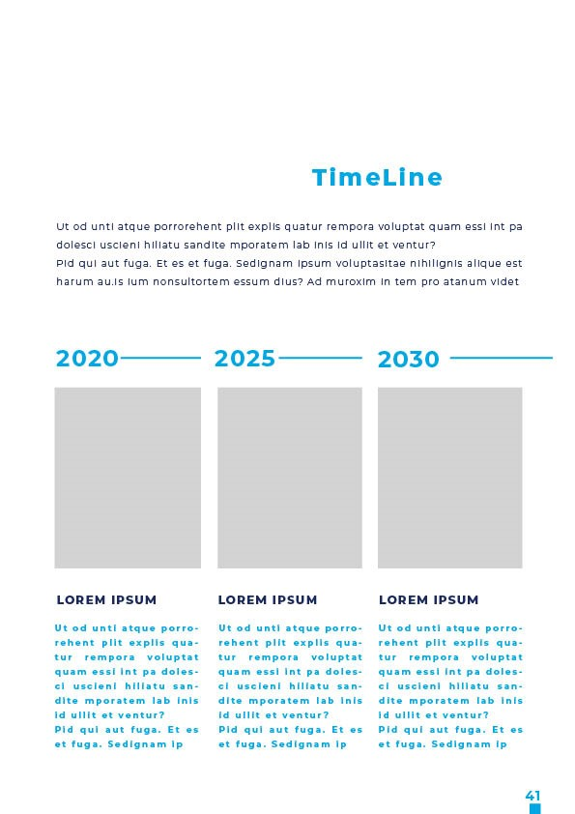

Appendix 1 - Evidence review

Definition of Cultural and Creative Industries
Culture and the creative industries together make up a ‘mixed economy’ of commercial and ‘not-for-profit’ creative enterprises, ranging from individual artists to large institutions to multinational corporations. The broader definition of culture spans cultural heritage, performance and celebration, visual arts and crafts as well as other creative industries, including music, and film and television. Heritage (including historic buildings, industrial and natural heritage, and parks) and sport also play a significant role in Liverpool’s cultural life, and its visitor offer. These elements of cultural consumption have a major impact on the city’s economy, both directly (through employment and admission fees) and indirectly (through money spent in the hospitality, travel and retail sectors). Culture Liverpool’s activities include management and promotion of heritage, historic buildings and sporting events, as well as arts and culture.
There is a high degree of crossover between cultural and creative industries. The ‘arts and culture’ and ‘crafts’ sub-sectors have a significant number of for-profit operators; and not all non-profit creative organisations are cultural – for example, digital non-profits delivering social outcomes in the so-called ‘Tech4Good’ sector. Public investment plays a proportionally greater role in cultural activity, and not-for-profit organisations may receive funding from a variety of sources – Liverpool City Council, trusts and foundations, individual donors, corporate sponsors, Arts Council England, National Lottery Heritage Fund and others. However, the activities, spend and employment of such funded non-profits still directly contributes to the city’s economy.
There is also a significant overlap between Liverpool’s third sector ecology – charities, community and voluntary sector organisations - and the city’s creative economy. This presents opportunities to enhance diversity, social benefits, innovation, and inclusive economic growth, working with and exchanging knowledge and best practice between the two sectors.
Estimates of the scale of Cultural and Creative Industries (CCI) in Liverpool follow the sector definition used by the Department for Digital, Culture, Media & Sport (DCMS) to define ‘the Creative Industries’. The industries included are defined by Standard Industrial Classifications (SIC). The determination of which activities constitute the Creative Industries is determined by the proportion of creative workers within them, as defined by Standard Occupational Codes (SOC) associated with creative practice.
DCMS includes four sub-sectors that make-up its definition of the cultural industries:
- Crafts
- Film, TV, Video, Radio and Photography
- Museums, Galleries and Libraries
- Music, Performing Arts and Visual Arts
and adds to these a further five sub-sectors of the creative industries:
- Advertising and Marketing
- Architecture
- Design: Product, Graphic and Fashion Design
- IT, Software and Computer Services
- Publishing
A full list of Cultural and Creative Industries SIC and SOC codes can be found in the appendices, along with a list of the LinkedIn industry definitions used to establish the size of the creative workforce

Use of innovative data sources
Many mapping reports rely on Office of National Statistics (ONS) data from the Business Register and Employment Survey (BRES). This leads to weaknesses and gaps in the data:
- BRES is published annually, typically around October, and reflects figures for the previous calendar year. This means that the most recent data available is for 2018.
- BRES employment data is based on a national survey of around 85,000 businesses. The response rate for the 2018 BRES survey was 85.1%. This means that estimates are based on evidence from 2.8% of the total number of all businesses in the UK: the results give no indication of how many responses were from Liverpool based companies, or from those in the cultural and creative sectors.
- The BRES survey sample consists of companies making PAYE returns. This excludes many freelancers (who may not be employed at the time of the survey), the self-employed, and company directors of micro-enterprises who pay themselves through dividends. Since these types of employment are particularly prevalent in the cultural and creative industries, there has been a longstanding concern that this leads to an under-reporting of the scale of the sector.
The estimates of cultural and creative employment used to establish a baseline for Liverpool’s CCI were based instead on data from LinkedIn. LinkedIn has several advantages over BRES as a source of data for creative employment:
- It represents a ‘live’ record – individuals are more likely to keep their records up to date, particularly in sectors like these where LinkedIn is used to advertise people’s availability for work, and where there is an incentive to ensure that the individual’s portfolio of employment and skills is as up-to-date and complete as possible.
- LinkedIn has 28.3 million UK members, against a total 33.07 million people employed in the UK - about 85% of the total – a much larger sample size than BRES.
- LinkedIn reflects individuals of all employment statuses, and none; and therefore gives a more accurate picture of the total sector workforce than a survey of those paying PAYE.
Evidence for the number of creative enterprises in Liverpool was taken from Companies House records. The data reflect the number of active companies (at February 2020, immediately pre-lockdown) within the SIC codes used by DCMS to define cultural and creative industries. This revealed a much larger number of companies – about a third more – than the latest available ONS data. This discrepancy was significantly greater than the trend growth rate shown by analysis of a time series of ONS data going back to 2010. The result is an invaluable baseline for the total number of active creative enterprises in Liverpool immediately prior to the COVID emergency, and one that can be used to measure the effectiveness of measures to recover, re-establish and grow the sector over the ten year lifetime of this plan.

Creative employment - pre-COVID-19 CCI workforce of 24,000+
Figure 6 Creative employment in Greater Liverpool
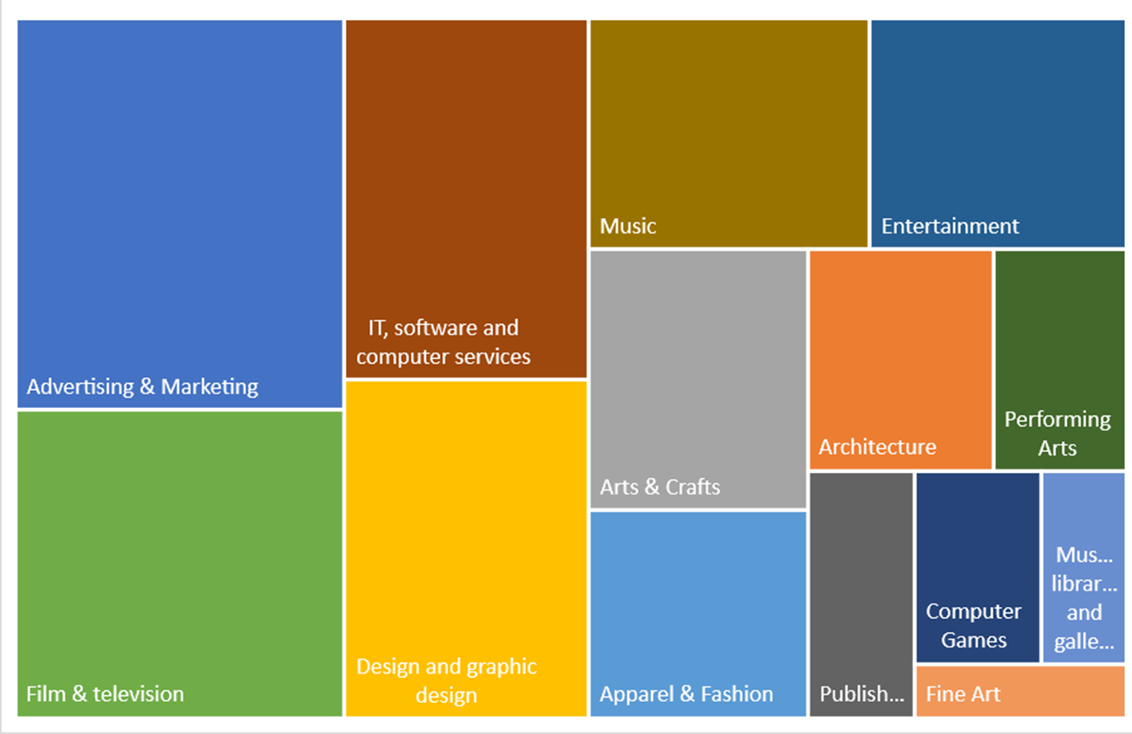
Source: City Curator/The Fifth Sector, March 2020

The estimate of Liverpool’s cultural and creative workforce was arrived at by a keyword search (by industry) of LinkedIn profiles of individuals who identified their location within the ‘Greater Liverpool’ area, as defined by LinkedIn. This equates to the Liverpool City Region and reflects the core cultural and creative workforce within the ‘travel to work’ area of Liverpool. Although a proportion of this workforce will commute out of the area for work – particularly to Manchester – this is balanced out by an element of inbound commuting from Manchester, Cheshire, Warrington, Lancashire and North Wales.
This analysis identified more than 22,000 records of cultural and creative workers in Greater Liverpool; this number was adjusted to reflect the difference between the number of registered LinkedIn users and total employment in Liverpool City Region, to give a total of some 24,000 cultural and creative workers.
By comparison, latest available Office of National Statistics (ONS) data show only 13,000 workers in CCI sectors, of whom 10,000 were full time employees (working 30 hours or more each week). This suggests as much as 60% of Liverpool’s creative workforce – some 14,000 people – are either self-employed, part-time, working as ‘freelancers’ or in microbusinesses which do not make PAYE returns (directors paying themselves through dividends.)
The treemap above illustrates the proportion of those workers in different cultural and creative sub-sectors. These have been calculated by aggregating numbers of workers within industry definitions used by LinkedIn both to reflect both the DCMS sub-sector definitions, and to highlight the structural differences between the cultural sector in Liverpool and the national picture. Specifically, they identify the DCMS subsector of ‘music, performing and visual arts’ under the separate headings of music, entertainment, performing arts, and arts and crafts. This more clearly demonstrates the scale of the live music and events sector in Liverpool and reflects how important live events are to the city’s creative and visitor economy.
It also hints at a structural weakness in the city’s creative economy: as a sector made up overwhelmingly of micro-enterprises and lacking a television broadcaster or other large content commissioning organisation, it is arguably overdependent on ‘footfall’-based businesses, and on Culture Liverpool’s role as a major events producer. The Culture Liverpool Action Plan will address the need to stimulate collaborative R&D to help creative enterprises generate original intellectual property (IP) to secure repeat revenues and drive up productivity over the long term.

Creative enterprises in Liverpool
Analysis of Companies House data confirms the impression that music, visual and performing arts enterprises make up a larger proportion of the cultural and creative sector in Liverpool than the UK average. This subsector is second only in size to the IT, software and computer services industry – which includes computer games (16 publishers and 82 games developers), app developers and other digital agencies whose output is primarily in the form of original content.

Figure 7 Sector breakdown of cultural and creative industries enterprises in Liverpool
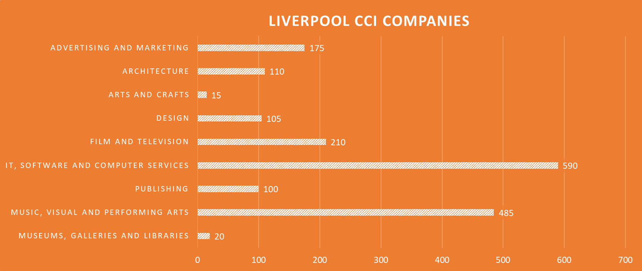
Source: City Curator/The Fifth Sector, March 2020

Clustering of creative enterprises
Unsurprisingly, just under half of the city’s creative enterprises – 820 out of 1,810 - were found to be clustered in Liverpool City Centre. The growth of the Baltic Triangle over the last decade is reflected in the large number of businesses to South of the Central Business District; the analysis also highlights the emergence of the North Docks area as a creative business location.
Figure 8 Clustering of creative enterprises in Liverpool City Centre
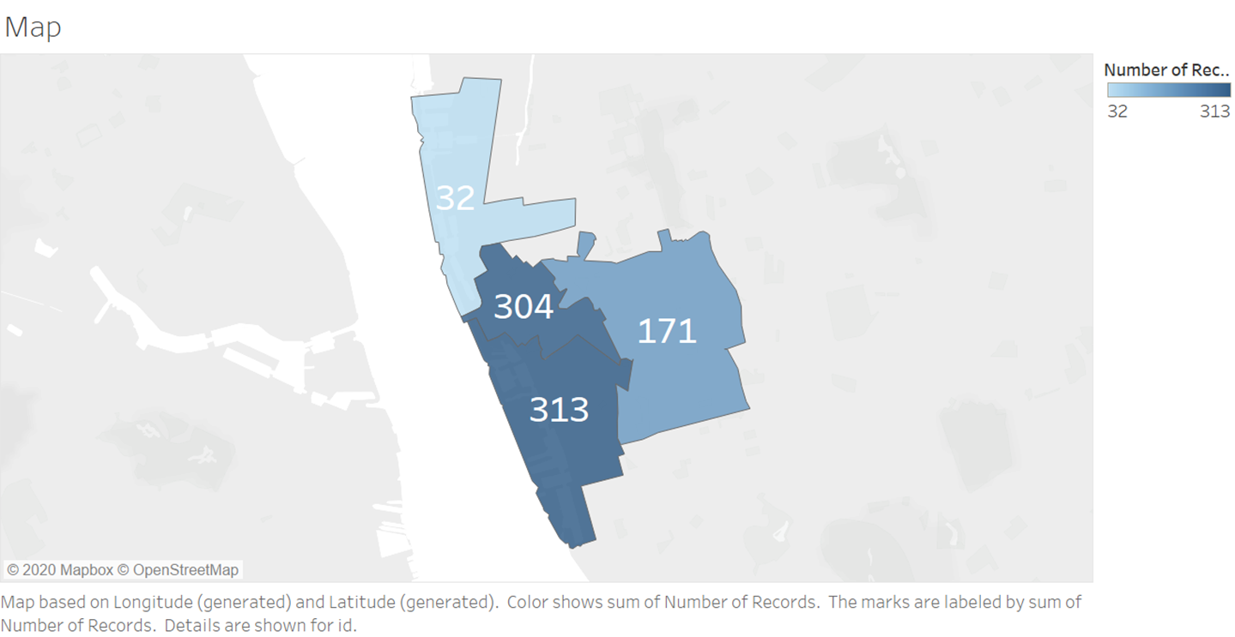
Source: City Curator/The Fifth Sector, March 2020

SWOT analysis
Figure 9 SWOT Analysis
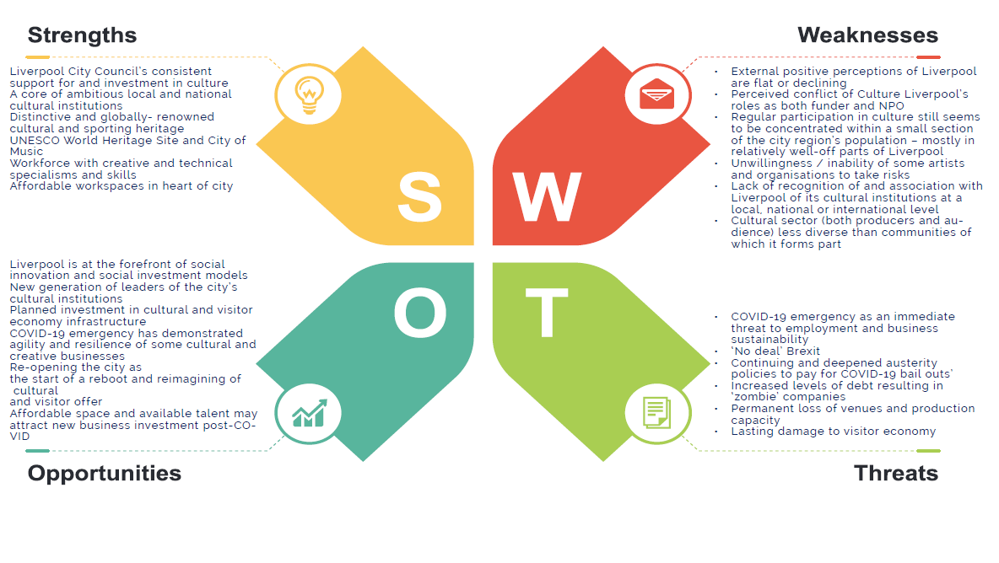

Appendix 2 – Consultees

Culture Liverpool and the consultants could not have produced this strategy without the generous and insightful input from its partners. Organisations which have contributed to this consultation include:

Arts Council England
British Council
Creative Industries Council
Creative England
Creative Industries Federation
Liverpool City Region Combined Authority
Baltic Creative CIC
Everyman Playhouse Theatres Trust
Institute of Cultural Capital
Liverpool John Moores University
University of Liverpool
Liverpool Institute of Performing Arts
Liverpool Hope University
Edge Hill University
Liverpool Arabic Arts Festival
Liverpool Irish Festival
Milapfest
The Extraordinary Club
Royal Liverpool Philharmonic
Creative Skillset
Cultural & Creative Skills
Liverpool Cultural Education Partnership
Ariel Trust
Liverpool Film Office
20 Stories High
Royal Court Theatre
The Kazimier
Writing on the Wall
DaDaFest
Draw & Code
Sound City
Make Liverpool
Parrjazz
The Women’s Organisation
Liverpool Heritage Development Co.
ACC Liverpool
National Museums Liverpool
Granby CLT
Liverpool Audio Network
The Black-E
Liverpool Biennial
The Bluecoat
Tate Liverpool
Open Eye Gallery
Kuumba Imani Millennium Centre
Metal
Hi Impact
Collective Encounters
Refractive Pool
Liverpool Artists Network
Arts In Liverpool
The Reader
Eureka Merseyside
Downtown Business In Liverpool
Wirral BC
Sefton MBC
St Helens Council
Arriva Northwest
Homotopia
Heart of Glass
Liverpool FC

Appendix 3 - DCMS Creative Industries Standard Industrial Classifications
The Standard Industrial Classifications (SIC) used by DCMS to define Cultural and Creative Industries are:

Cultural Industries
Crafts
- Manufacture of jewellery and related articles
Film, TV, Video, Radio & Photography
- Motion picture, video and television programme production activities
- Motion picture, video and television programme postproduction
- Motion picture, video and television programme distribution
- Motion picture projection activities
- Radio broadcasting
- Television programming and broadcasting activities
- Photographic activities
Museums, Galleries and Libraries
- Library and archive activities
- Museum activities
Music, Performing and Visual Arts
- Sound recording and music publishing activities
- Cultural education
- Performing arts
- Support activities to performing arts
- Artistic creation
- Operation of arts facilities

Creative Industries
Advertising & Marketing
- Public relations and communication activities
- Advertising agencies
- Media representation
Architecture
- Architectural activities
Design: product, graphic and fashion design
- Specialised design activities
IT, Software & Computer Services
- Publishing of computer games
- Other software publishing
- Computer programming activities
- Computer consultancy activities
Publishing
- Book publishing
- Publishing of directories and mailing lists
- Publishing of newspapers
- Publishing of journals and periodicals
- Other publishing activities
- Translation and interpretation activities

Appendix 4 - DCMS Standard Occupation Codes
The frequency of these Standard Occupational Codes as a proportion of sector employment is used by DCMS to determine the component parts of the Cultural and Creative industries – with a minimum threshold of 30%.

Cultural industries
Crafts
- Smiths and Forge Workers
- Weavers and Knitters
- Glass and Ceramics Makers, Decorators and Finishers
- Furniture Makers and Other Craft Woodworkers
- Other Skilled Trades Not Elsewhere Classified
Film, TV, Video, Radio & Photography
- Arts Officers, Producers and Directors
- Photographers, Audio-Visual and Broadcasting Equipment Operators
Music, Visual & Performing Arts
- Artists
- Actors, Entertainers and Presenters
- Dancers and Choreographers
- Musicians
Museums, Galleries & Libraries
- Librarians
- Archivists and Curators

Creative Industries
Advertising & Marketing
- Marketing and Sales Directors
- Advertising and Public Relations Directors
- Public Relations Professionals
- Advertising Accounts Managers and Creative Directors
- Marketing Associate Professionals
Architecture
- Architects
- Town Planning
- Chartered Architectural Technologists
- Architectural and Town Planning Technicians
Design: Product, Graphic and Fashion Design
- Graphic Designers
- Product, Clothing and Related Designers
IT, Software & Computer Services
- Information Technology and Telecommunications Directors
- IT Business Analysts, Architects and Systems Designers
- Programmers and Software Development Professionals
- Web Design and Development Professionals
Publishing
- Journalists, Newspaper and Periodical Editors
- Authors, Writers and Translators

Appendix 5 – LinkedIn industry codes
The table below indicates how LinkedIn Industry descriptors were mapped onto the set of Standard Industrial Classifications used by DCMS to define cultural and creative industries.

DCMS CI grouping | SIC |  | Linkedin Industry classification
Cultural Industries
Crafts | 3212 : Manufacture of jewellery and related articles |  | Luxury goods and jewellery
Film, television, video, radio and photography | 18202 : Reproduction of video recording |  | Motion pictures and Film, Broadcast Media
 | 18203 : Reproduction of computer media |  | Motion pictures and Film, Broadcast Media
 | 5911 : Motion picture, video and television programme production activities |  | Motion pictures and Film, Broadcast Media
 | 5912 : Motion picture, video and television programme post-production activities |  | Motion pictures and Film, Broadcast Media
 | 5913 : Motion picture, video and television programme distribution activities |  | Motion pictures and Film, Broadcast Media
 | 5914 : Motion picture projection activities |  | Motion pictures and Film, Broadcast Media
 | 6010 : Radio broadcasting |  | Broadcast Media
 | 6020 : Television programming and broadcasting activities |  | Broadcast Media
 | 74201 : Portrait photographic activities |  | Photography
 | 74202 : Other specialist photography (not including portrait photography) |  | Photography
 | 74203 : Film processing |  | Photography
 | 74209 : Other photographic activities (not including portrait and other specialist photography and film processing) n.e.c. |  | Photography
Music, performing and visual arts | 18201 : Reproduction of recorded media |  | Music
 | 3220 : Manufacture of musical instruments |  | Music
 | 4763 : Retail sale of music and video recordings in specialised stores |  | Music
 | 5920 : Sound recording and music publishing activities |  | Music
 | 8552 : Cultural education |  | [No equivalent]
 | 9001 : Performing arts |  | Performing arts
 | 9002 : Support activities to performing arts |  | Performing arts
 | 9003 : Artistic creation |  | Arts & Crafts, Fine Art
 | 9004 : Operation of arts facilities |  | Museums and Institutions
Museums, libraries and galleries | 91011 : Library activities |  | Libraries
 | 91012 : Archive activities |  | Libraries
 | 9102 : Museum activities |  | Museums and Institutions
 | 9103 : Operation of historical sites and buildings and similar visitor attractions |  | Museums and Institutions
Creative Industries
Advertising and Marketing | 7021 : Public relations and communication activities |  | Public Relations and Communications
 | 7311 : Advertising agencies |  | Marketing and Advertising
 | 7312 : Media representation |  | Public Relations and Communications
Architecture | 71111 : Architectural activities |  | Architecture and Planning
 | 71112 : Urban planning and landscape architectural activities |  | Architecture and Planning
Design | 7410 : Specialised design activities |  | Design  Graphic Design  Apparel & Fashion
IT, software and computer services | 5821 : Publishing of computer games |  | Computer Games
 | 5829 : Other software publishing |  | Computer Software  Computer & Network Security*
 | 62011 : Ready-made interactive leisure and entertainment software development |  | Computer Games
 | 62012 : Business and domestic software development |  | Computer Software  Computer & Network Security*
 | 6202 : Computer consultancy activities |  | Computer Software  Computer & Network Security*
Publishing | 5811 : Book publishing |  | Publishing
 | 5812 : Publishing of directories and mailing lists |  | Publishing
 | 5813 : Publishing of newspapers |  | Publishing
 | 58141 : Publishing of learned journals |  | Publishing
 | 58142 : Publishing of consumer, business and professional journals and periodicals |  | Publishing
 | 5819 : Other publishing activities |  | Publishing
 | 7430 : Translation and interpretation activities |  | Translation and Localization

* Companies within this Industry definition were manually analysed and only included if it was possible to determine whether their main output consisted of original content

Credits

Liverpool Cultural Strategy 2020-2030 researched and written by The Fifth Sector: Iain Bennett, Sara Sartorius, Jane Baker
Employment and workforce data provided by City Curator: Simon Sprince, Andy Goodwin
Thanks to:
Claire McColgan, Alicia Smith, Sean Durney and Culture Liverpool; Sarah Lovell at Liverpool City Region Combined Authority; and all those individuals and organisations, too numerous to name, who contributed case studies and insights to the study

Final version will include a text box here, and a more detailed appendix on LARC and COoL organisations, impacts and case studies of activities
Final version will include annex/pull-out highlighting achievements of cultural organisations
Case study to be included in final version
The Art of Inclusion: Liverpool’s Creative Community (2005)
Jo Verrent, Twitter thread entitled ‘Reimagine the arts’, 31 May 2020
Case study to follow in final version
Estimates for December 2019 to February 2020. Source: ons.gov.uk
UK Business Register and Employment Survey results for 2018, accessed via Nomisweb, January 2020
One quirk of the DCMS groupings is that the crafts SIC grouping focuses on jewellery, while the crafts SOC grouping has a broader focus.

